Installation & Introduction

* Download and install power bi x64
* Power BI has Public and enterprise version.
* In enterprise version we can host dashboard in company server, and we can collaborate with many people.
* 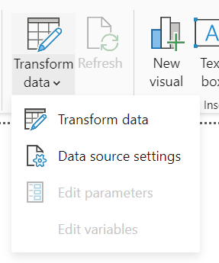 Isse hum data ko clean karte hai. Jaise outlier, null value, wrong data type etc.
* Insert tab is used to enhance visuals. Like insert button, image etc.
* 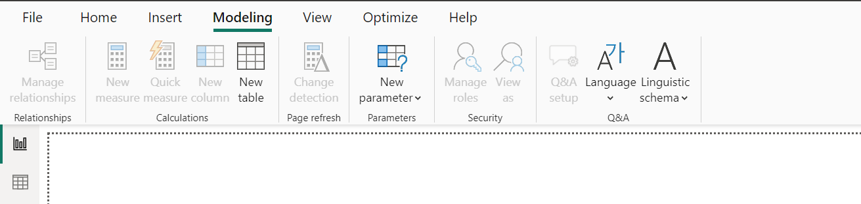
* Modelling is used to connect relationship between different data sources.
* 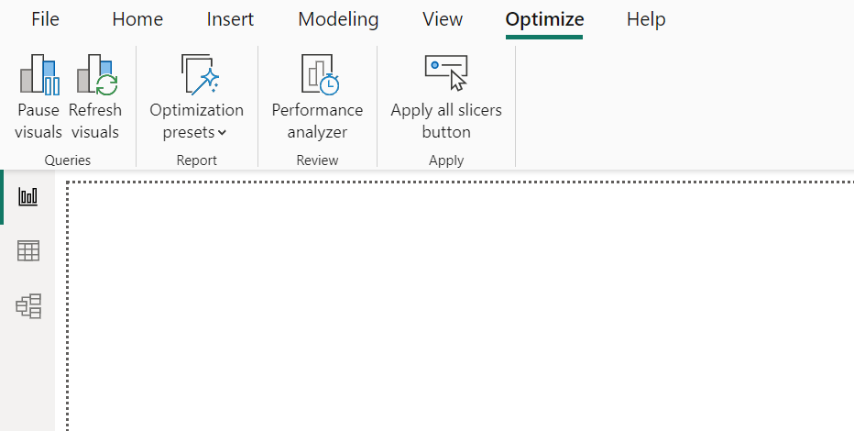
* Optimize is used for loading data in better/quickly way. If charts is taking too much time to load then we can optimize it from here. If some error is thrown then correct it from here.
* View is used for theme.
* 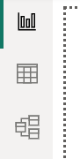
* Report view: Reports/Charts shown
* Table view: Excel/table is shown
* Model View: Entity relationship diagram. Tables are connected to each other. Primary Key and Foreign Key relationship.
* Single chart is called tile. Multiple tile is called dashboard.
* Lets import HR data in csv format -> Transform data -> Power Query Editor enter
* Filter: Apply filter to data or tile/charts on basis of some condition. Like marks >90
* Now, Import data from excel -> transform data ->ok
* <https://www.kaggle.com/datasets/pavansubhasht/ibm-hr-analytics-attrition-dataset/data> hr data set
* Once we load data, we enter power query editor-> it is a transformation tool which process data like cleaning, deleting, identifying etc.
* Most of the features commonly used here. 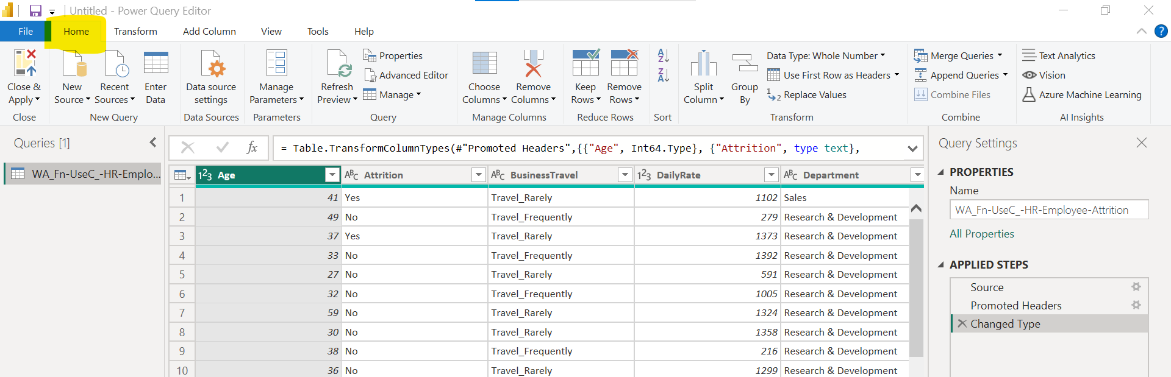
* Tranform/clean data. 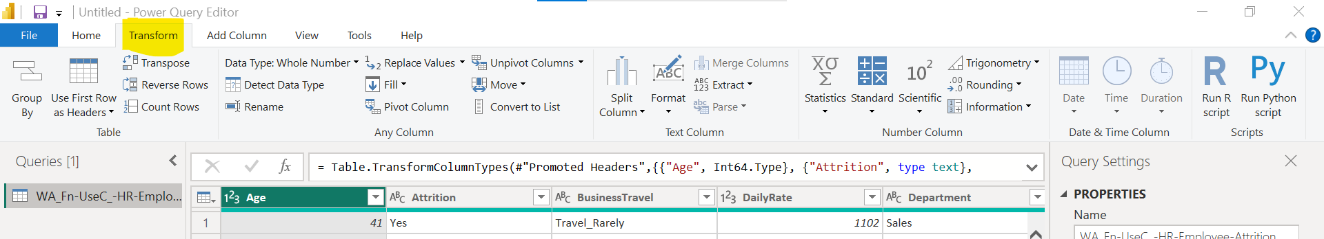
* We can use python script to clean data. We can add columns. Like DOB is given calclutae age.
* 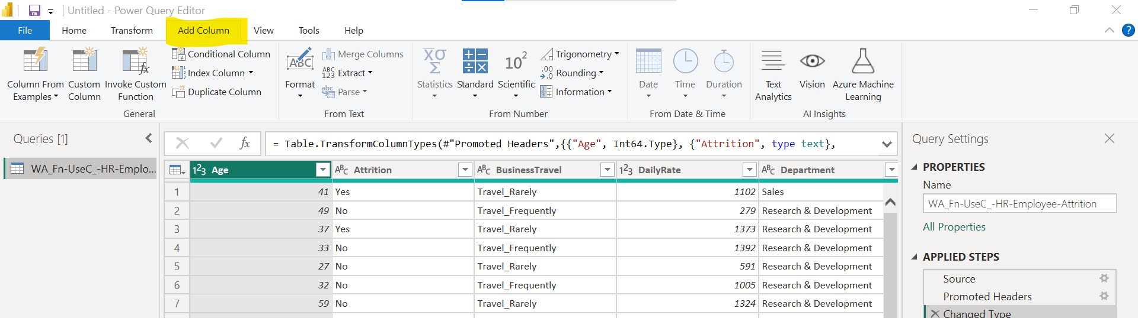
* This is mquery. 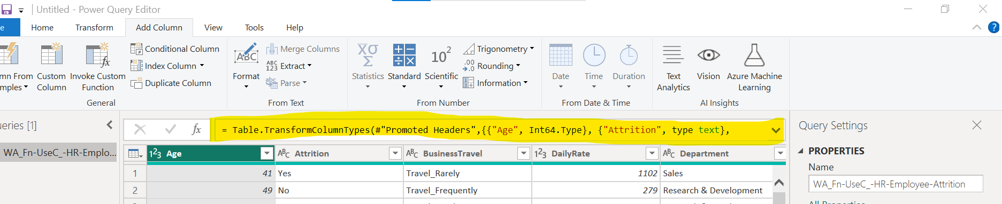
* All tables 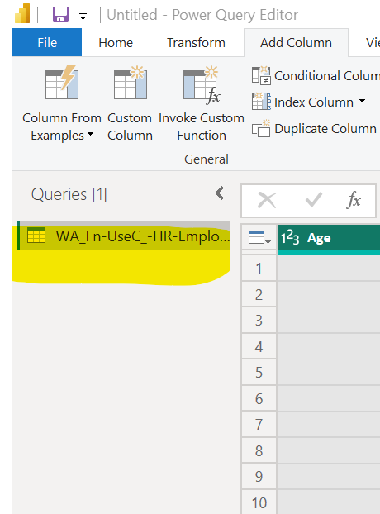
* All steps/process we do is shown here. 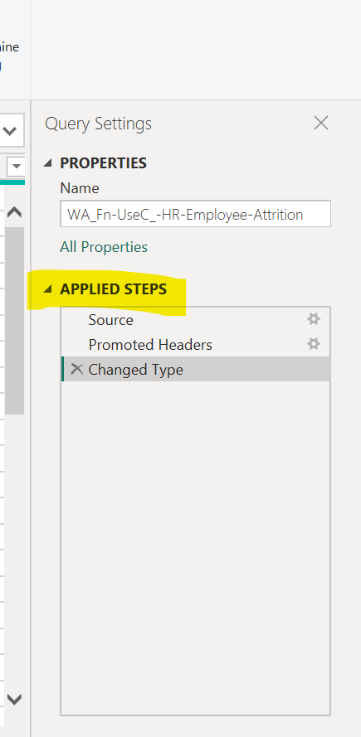
* We can delete steps to undo action.
* Lets start cleaning
  + Check column name appropriate hai yan hi.
  + Manually check data type still PowerBI assigns some data type.
  + We can merge columns and split as well. Like For first name and last name.
  + 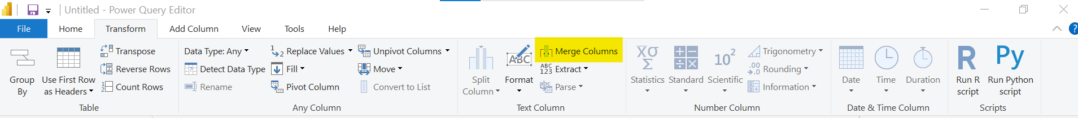
  + We can remove un-necessary column as well.
  + We can check null value by clicking on filter and see listed all value if null exists.
  + Or by column quality options. 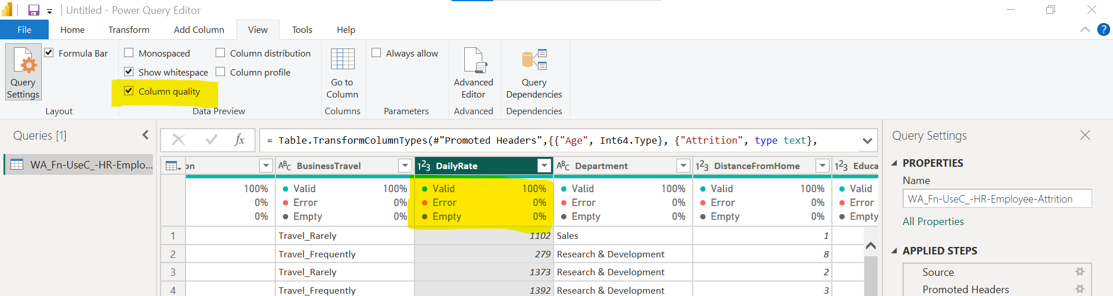
  + Remove null value row. 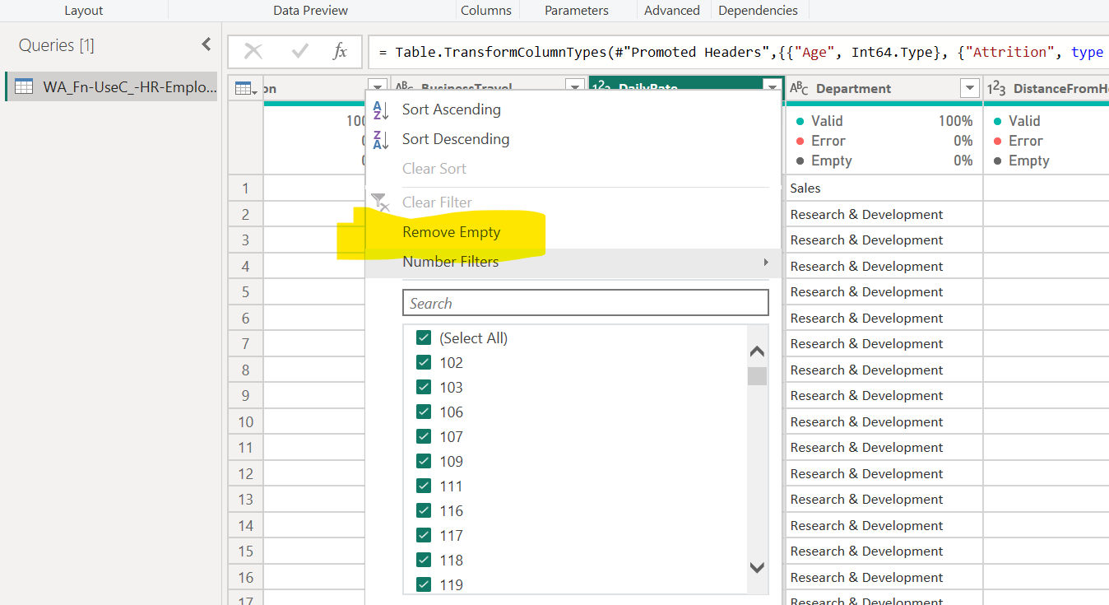
  + Based on condition we can remove rows. 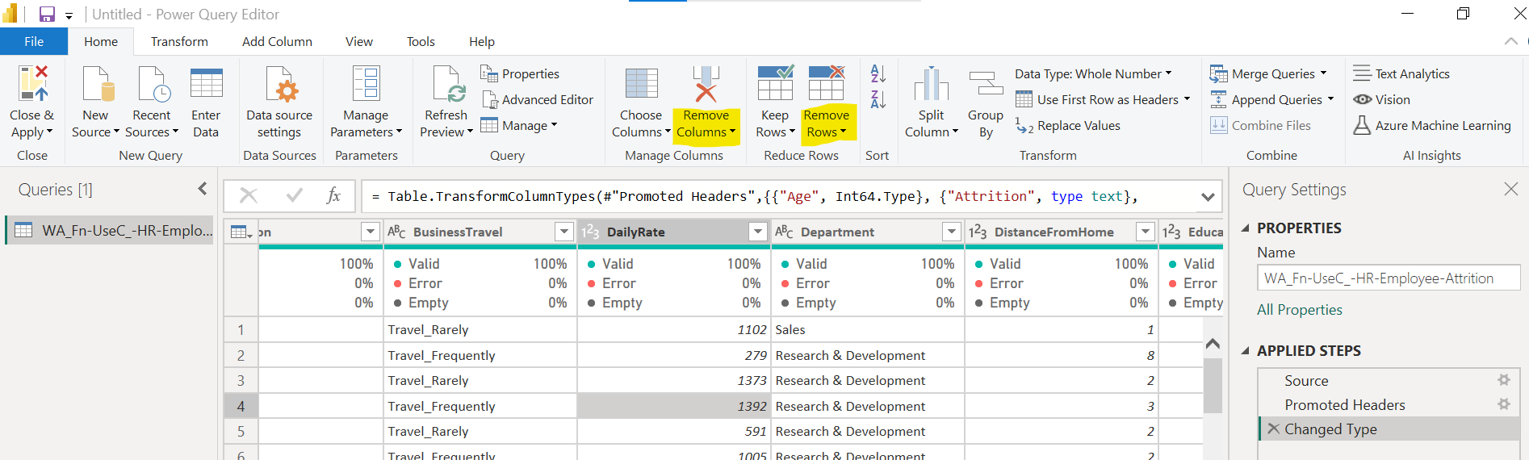
  + We can replace some value. Like nul or blank with mean, median, mode values.
  + If wehave very large dataset and only small data like 1% is null or empty then we can remove them then not much impact on our datasets. But if data is very small and null is more then we can not remove remove, it will lead to data loss. In this case we have to fix null values.
  + 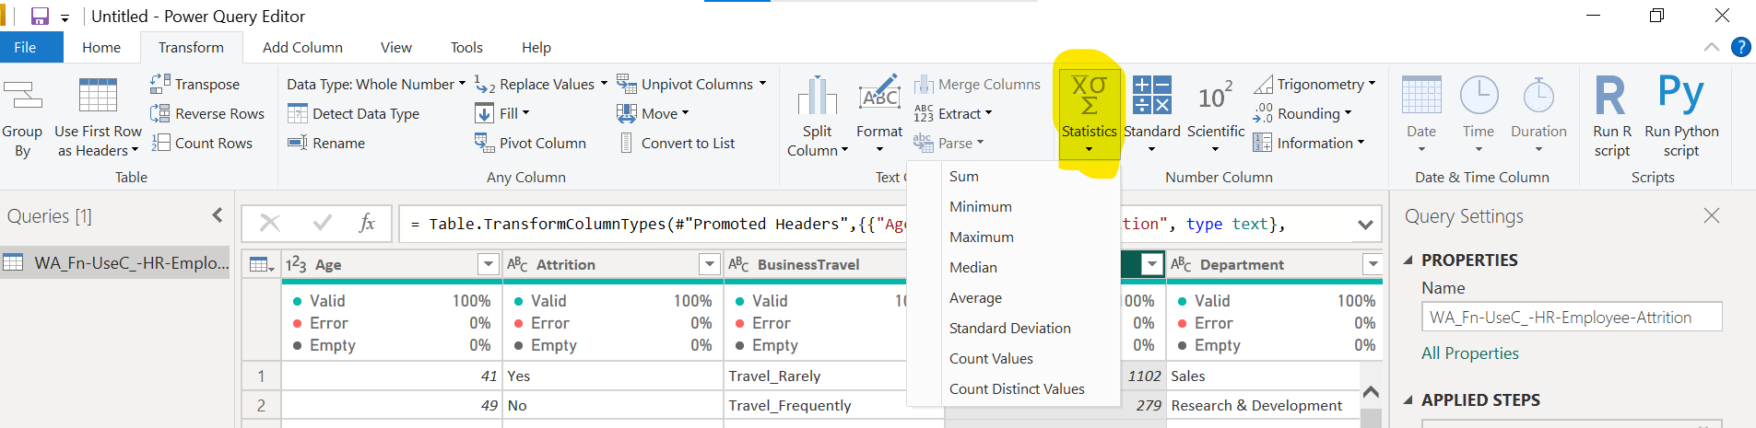
  + We can replace null with mead,median,mode values. Now, check column quality.
  + Remove duplicate data/rows 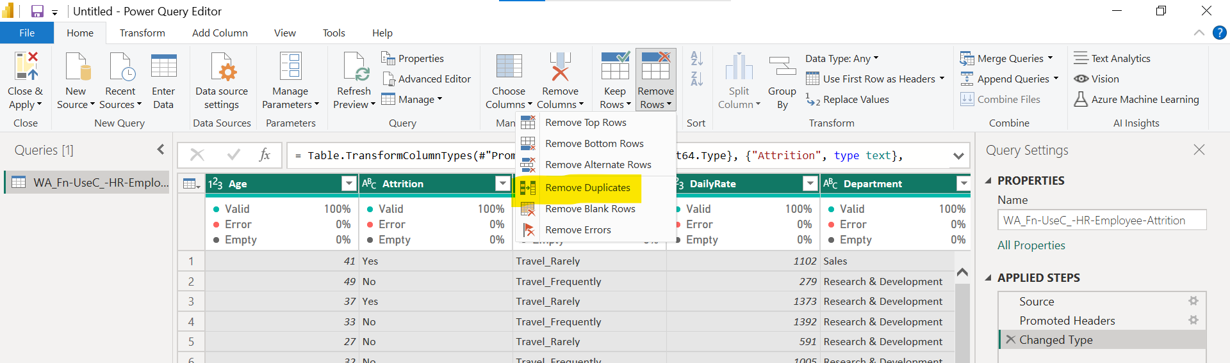
  + Removing column duplicates. 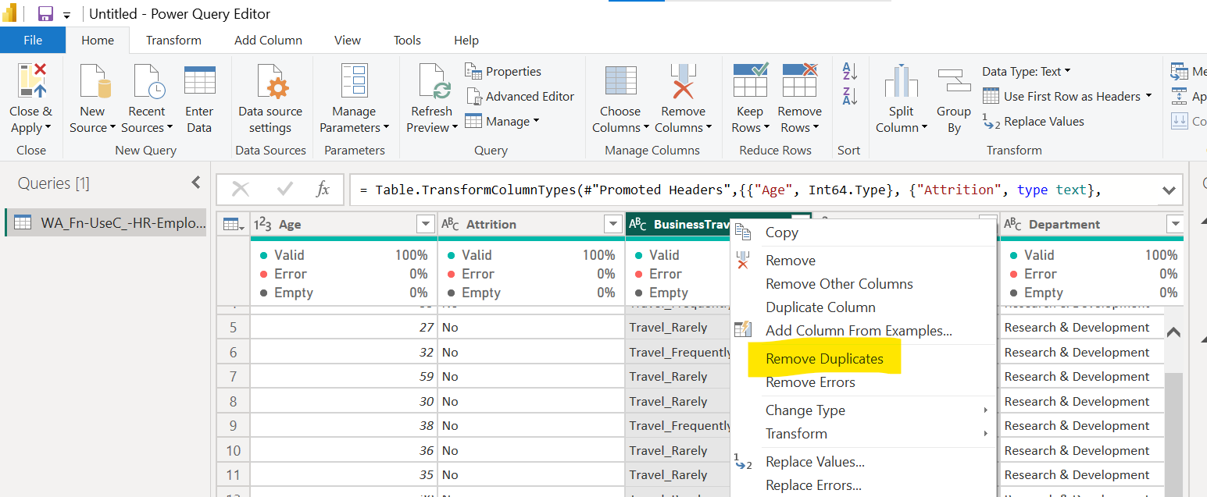
  + We can change column name by double clicking it.
  + Chage data type 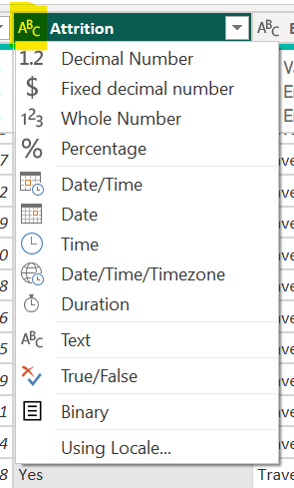
  + Or 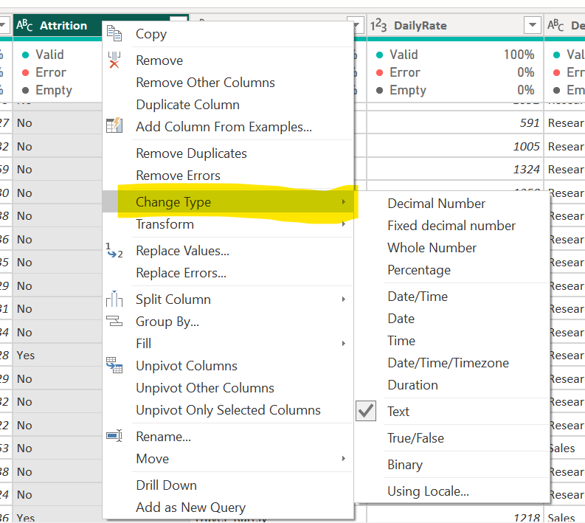
  + Close and apply finalise our data for ready to use in powerbi. 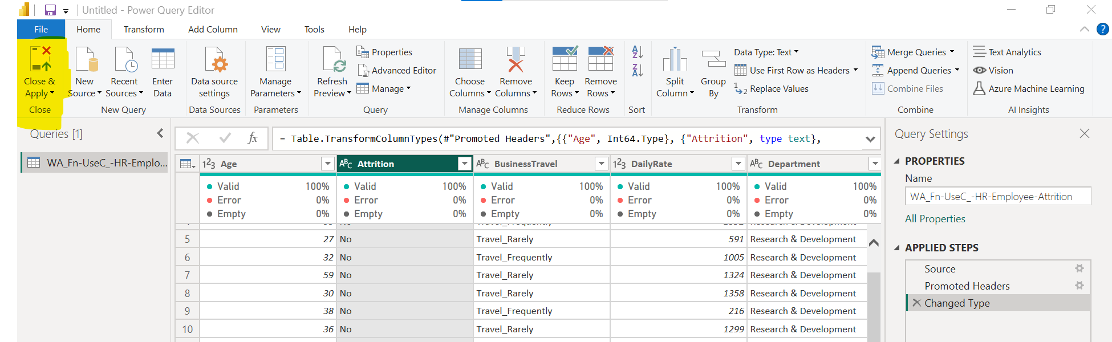
  + Again we can goto power query editor. 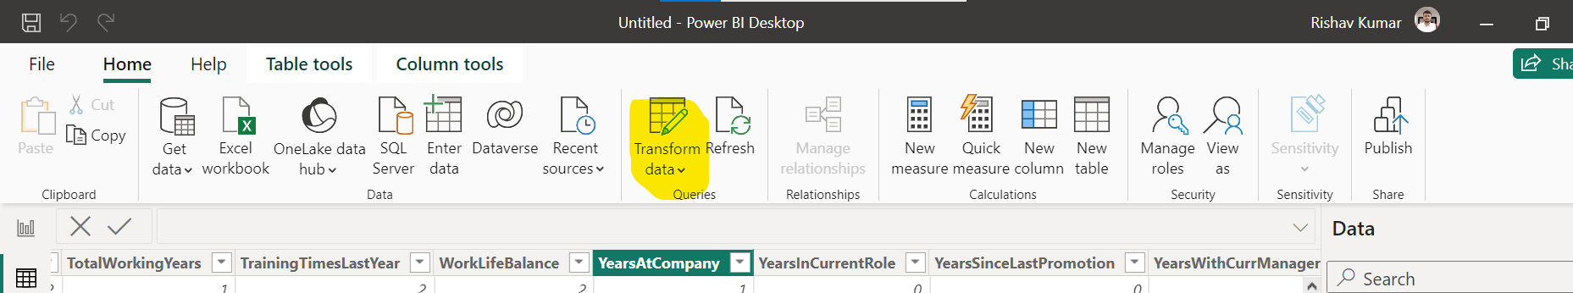
  + We can add column like this and apply some formula to get data. 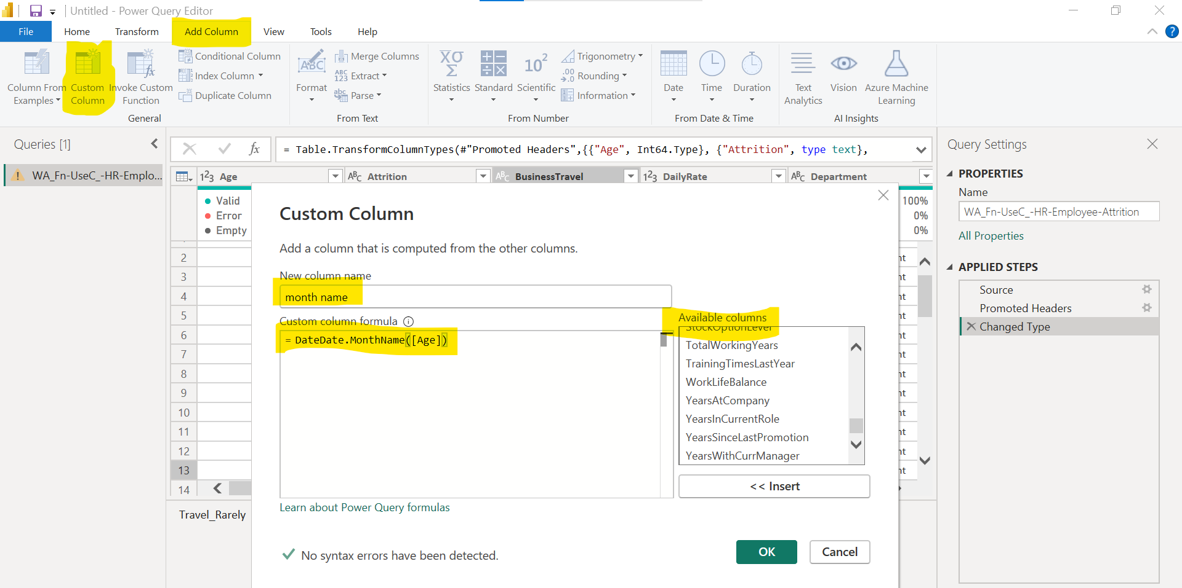
  + We can assign data type to column. It will helpful for analysis. 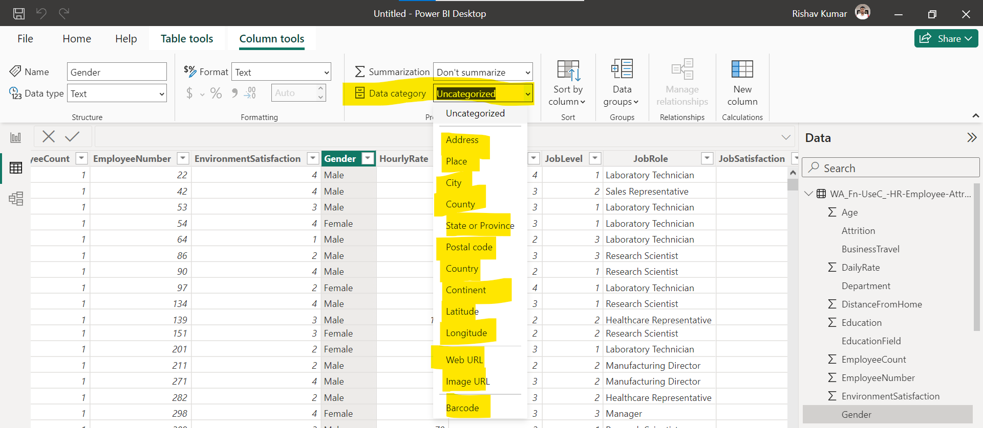
  + Bar or Line charts are used to represent categorical vs numerical feature. Like product vs sales 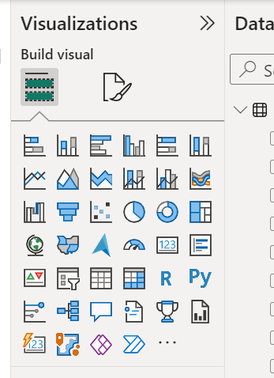
  + Ctrl+c, ctrl+v copy and paste charts
  + Use of filter on charts. 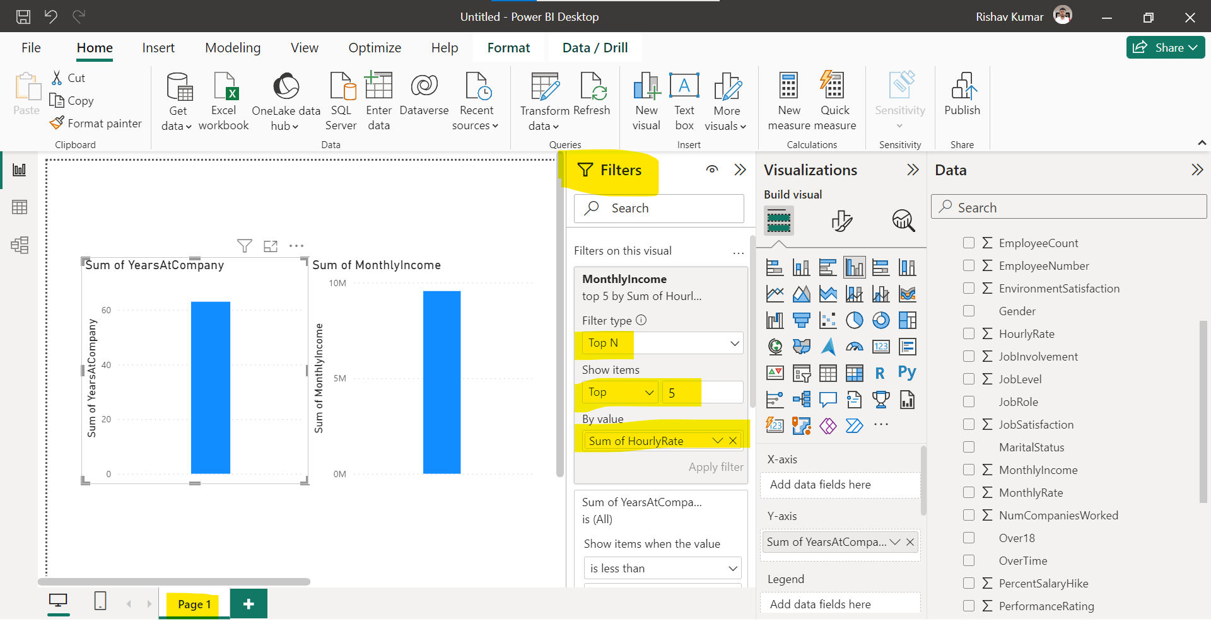
  + 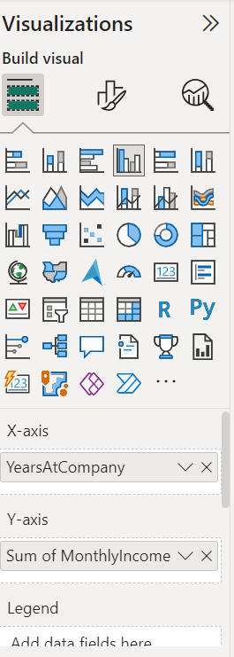 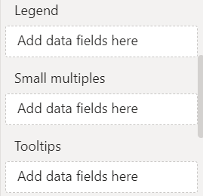 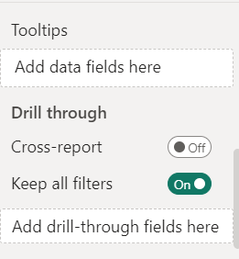
  + All charts and their usage: <https://mindmajix.com/power-bi-visualization-types>
* 3rd Lecture
  +  Use this sheet Sales data
  + Change data type to currencies of these 2 col 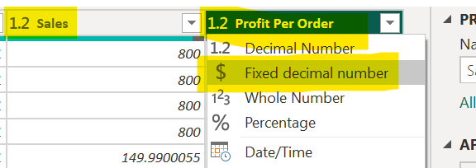
  + Remove redundant/duplicate column. 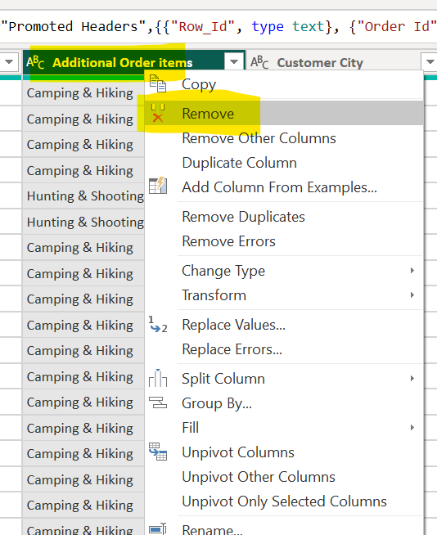
  + Adding new column. 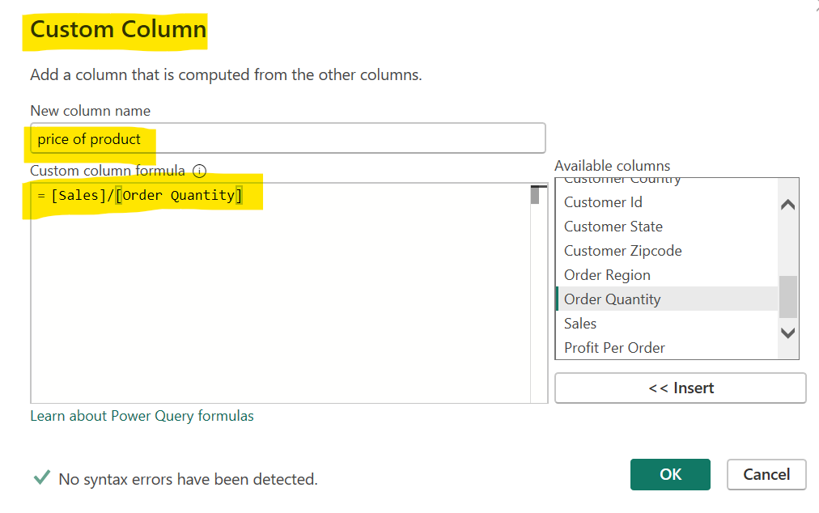
  + 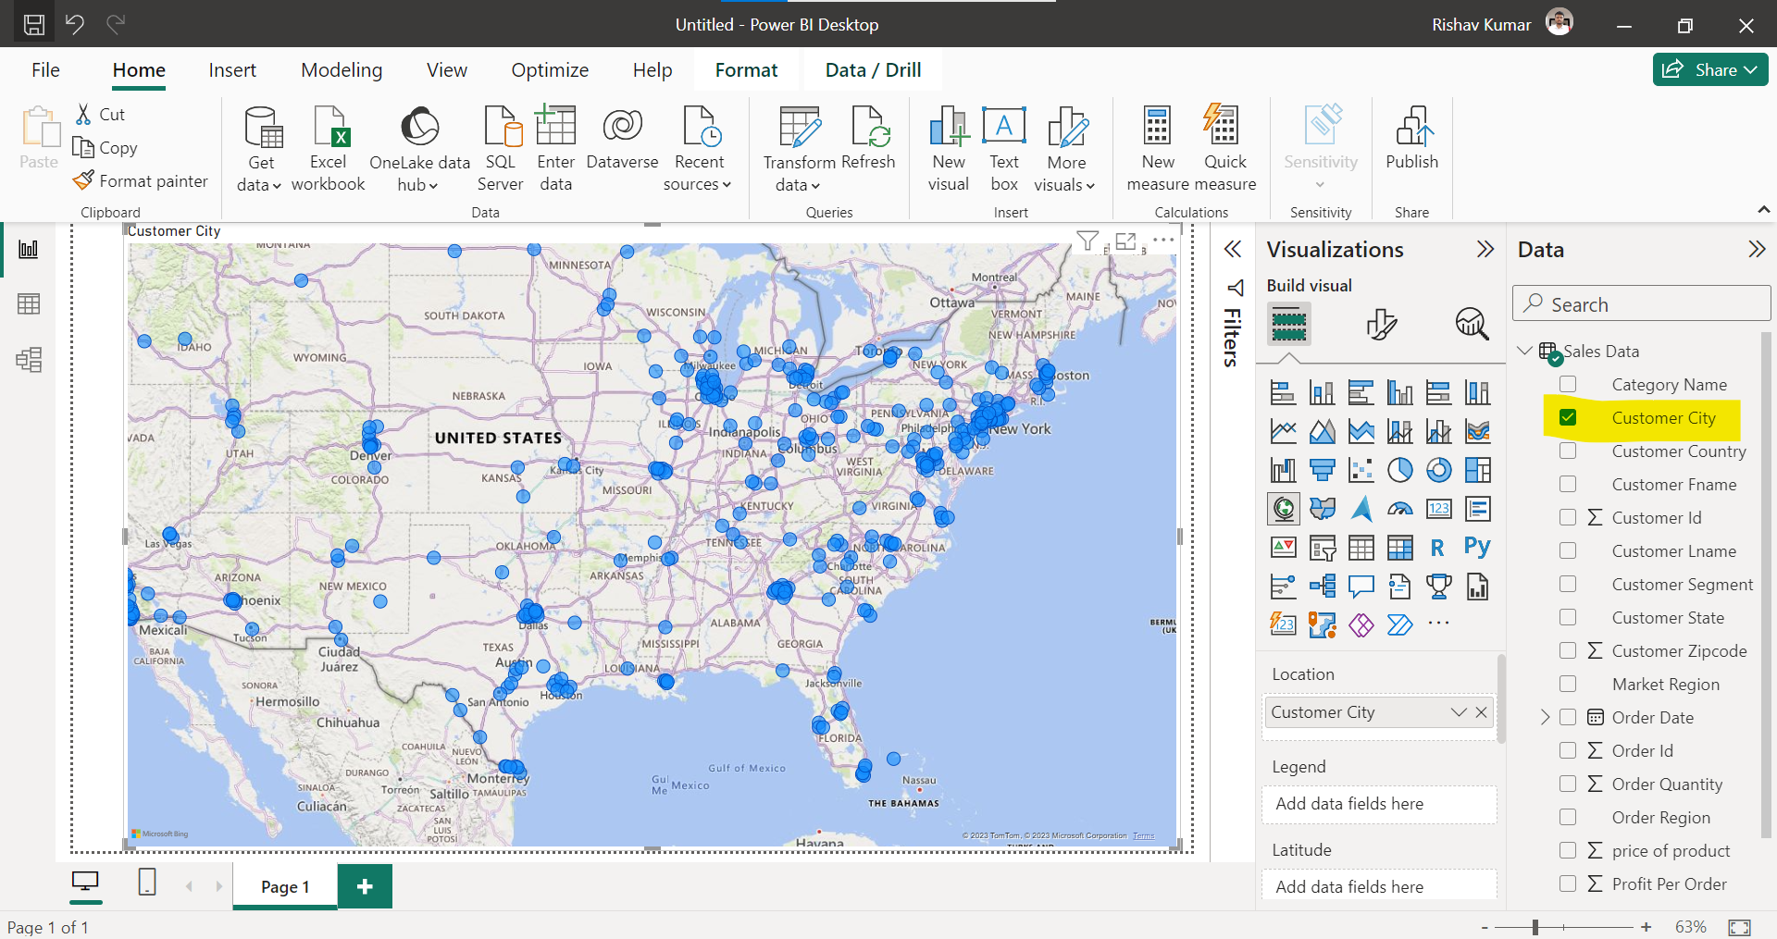
  + We can categorize from here as well. 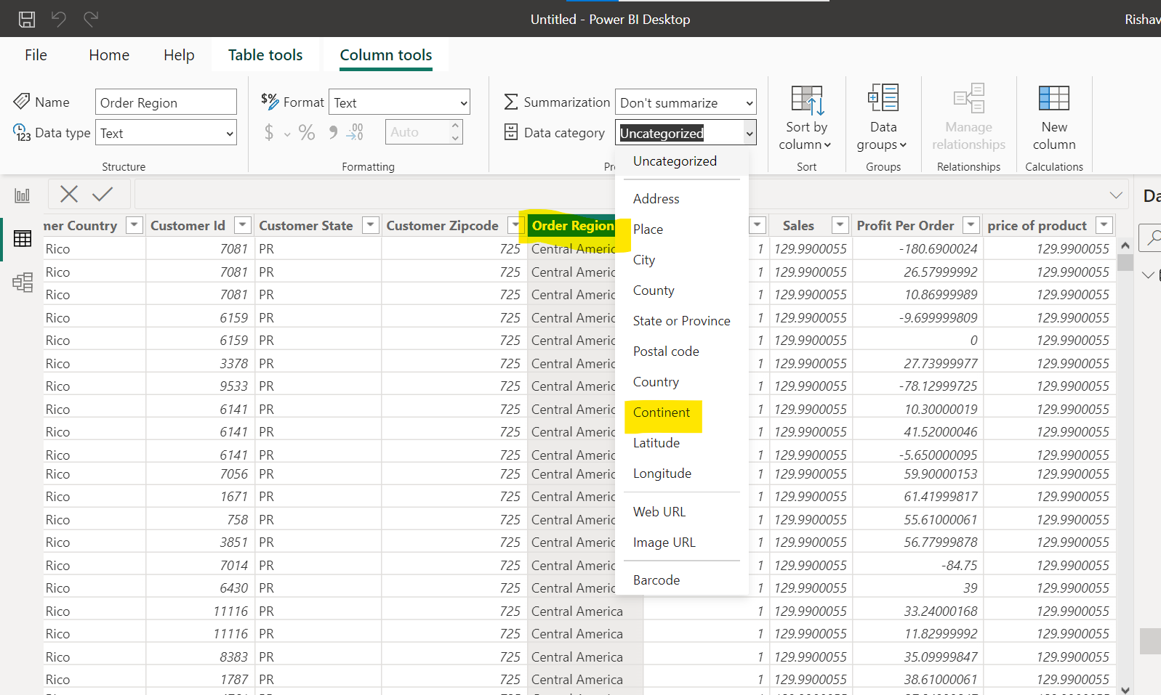
  + Bar Chart for categorical vs numerical feature. 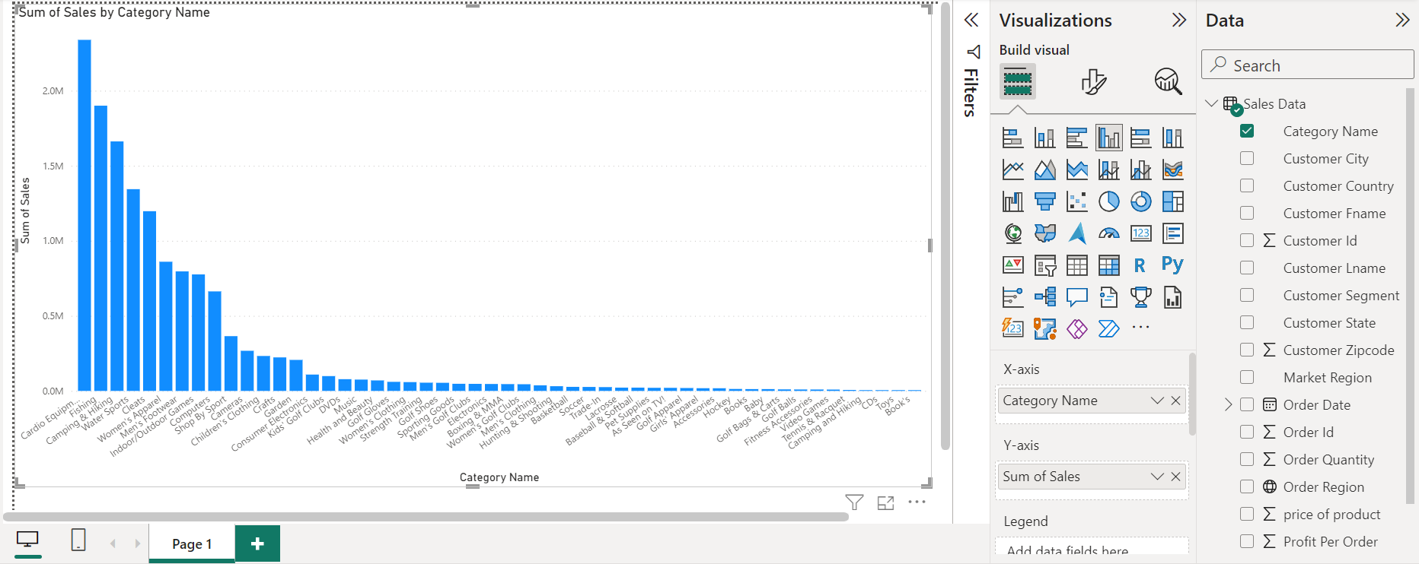
  + We can change data type from here as well. 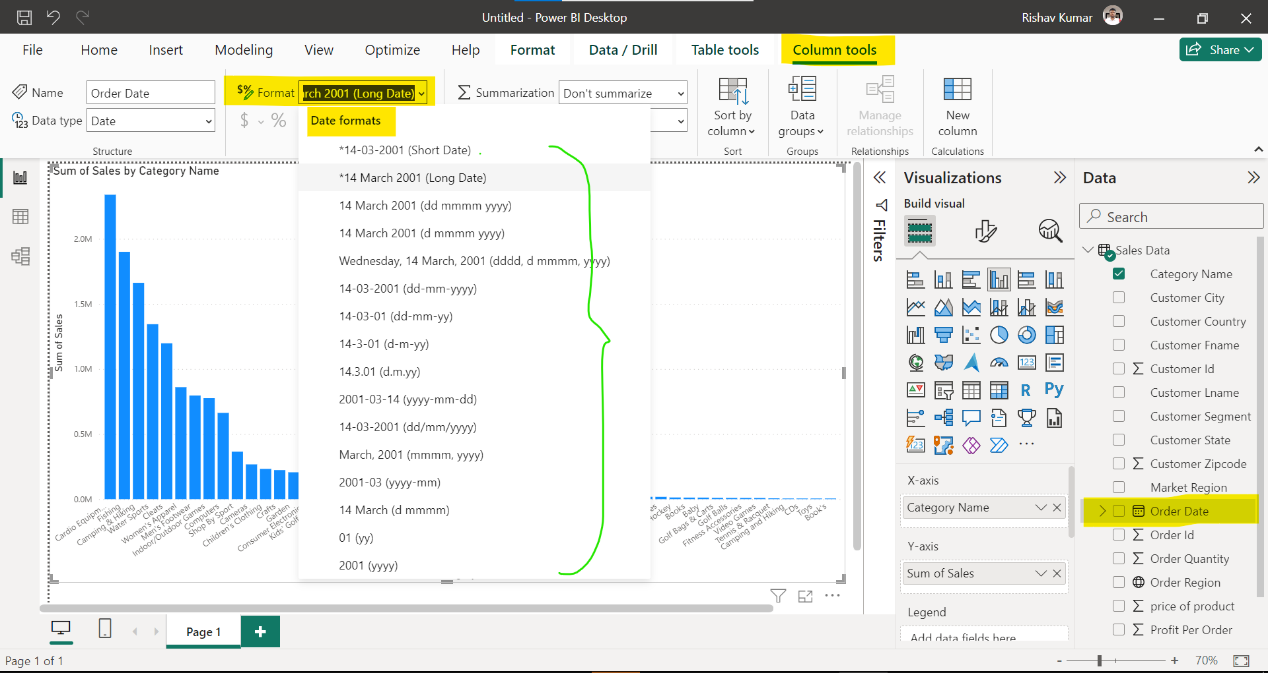
  + One column analysis: Univariate Two column: Bivariate Many: Multivariate
  + For multivariate we use legend to plot graph. 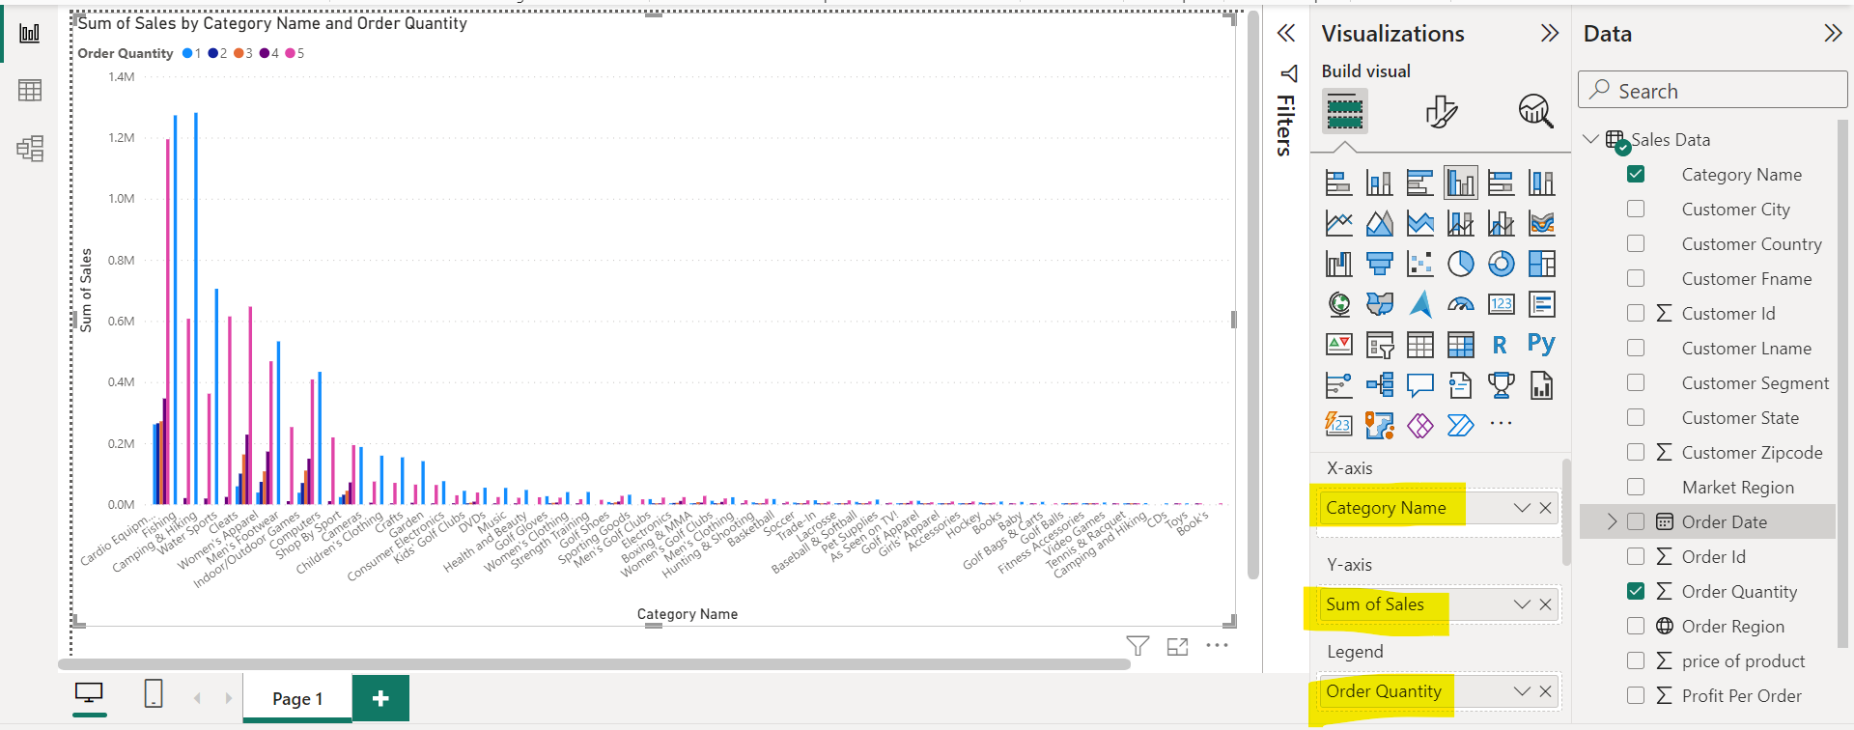
  + 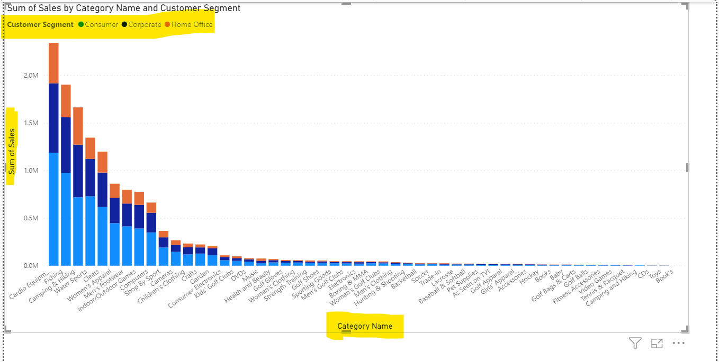
  + Tooltip is used to get additional information. 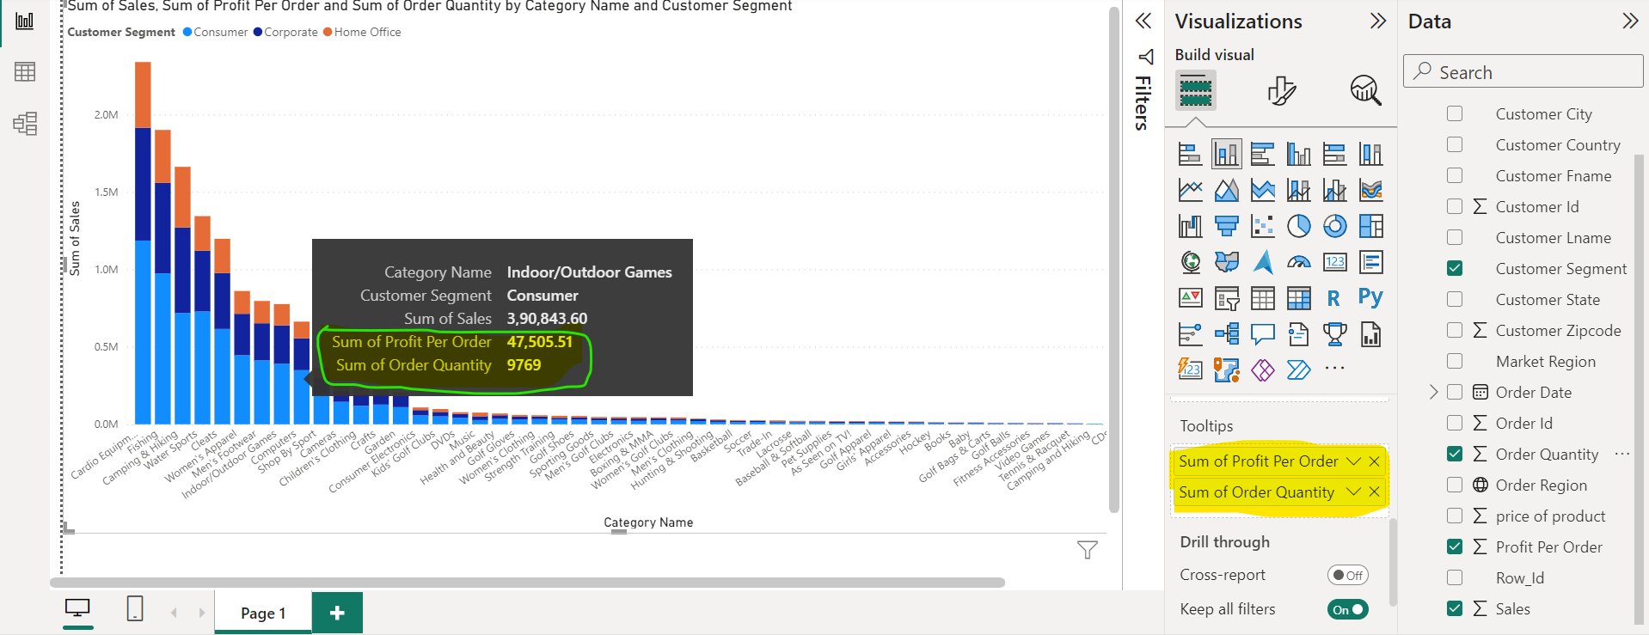
  + Small Multiple: It divided graph into chunk based on column. 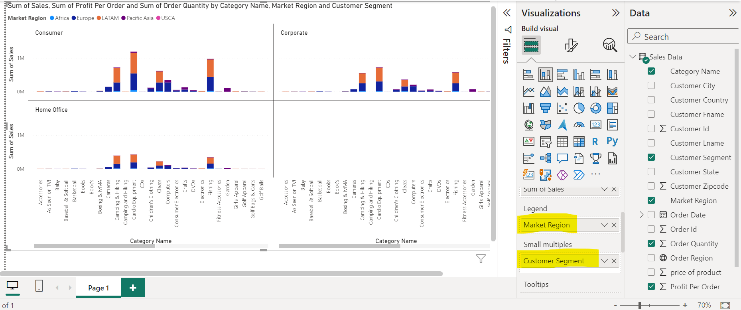
  + Jitna colm visualization me use karenge utne filter tabe me add honge. 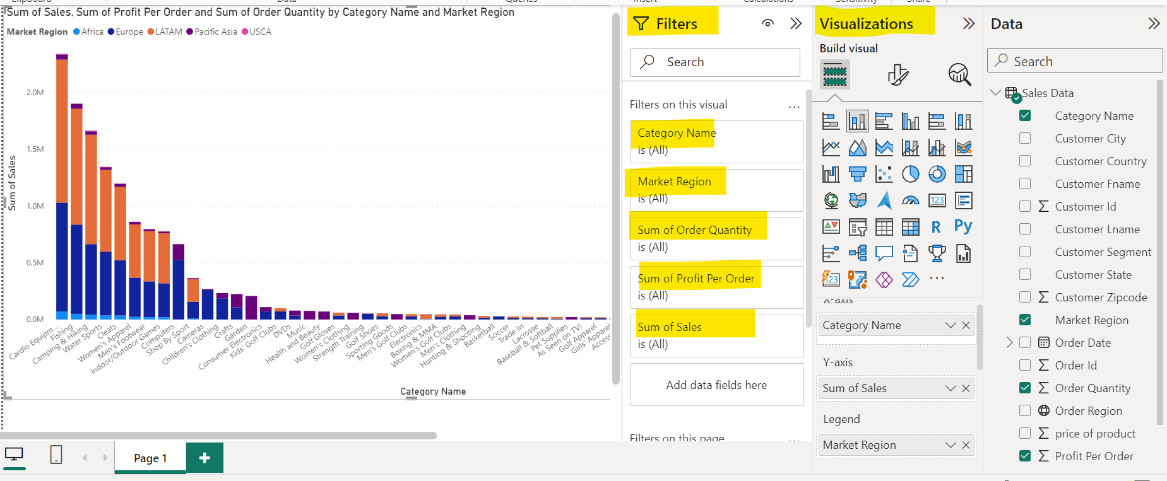
  + Applied filter 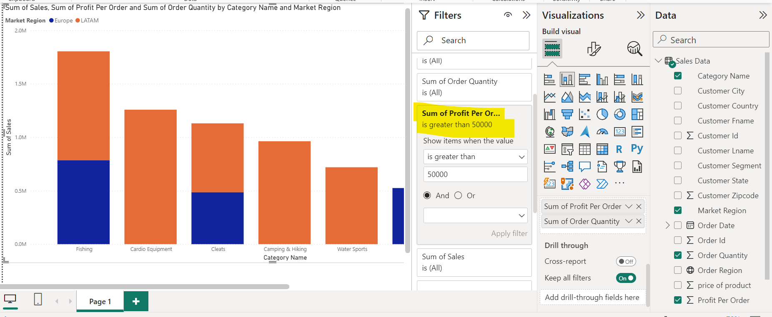
  + We can analyse sales over the period.
  + 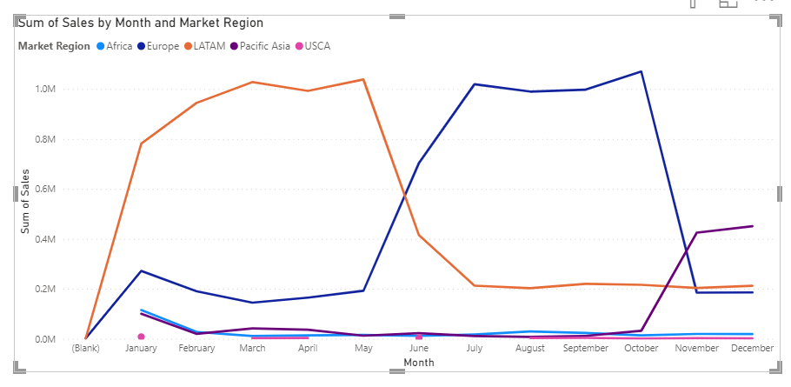
  + Funnel Chart
  + 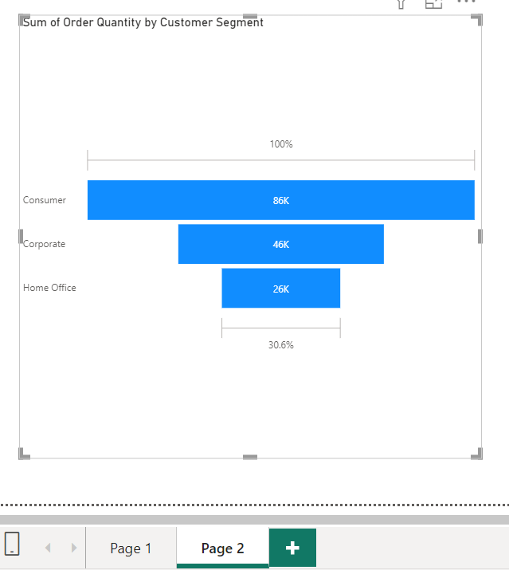
  + This is used when we want to understand process. E.g Interview first round mt kitne ke hue, 2nd round me kitne ke hue, 3rd rounf me kitne ke hue.
  + 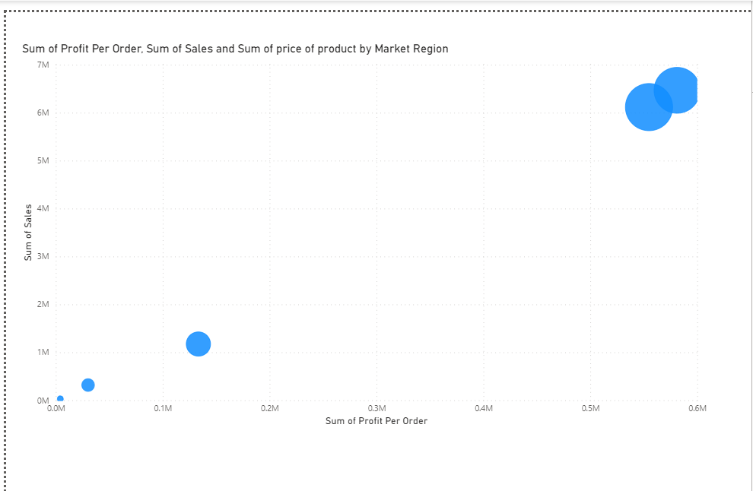
  + 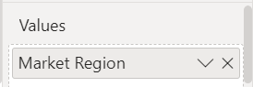 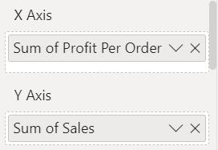 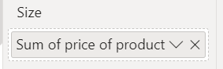
  + Size: Sum of price of product jha jyada hoga wha ball kis size jyada hogi, jha kum hoga wha small hogi.
  + Basically, size defines size of ball.
  + Donut Chart
  + 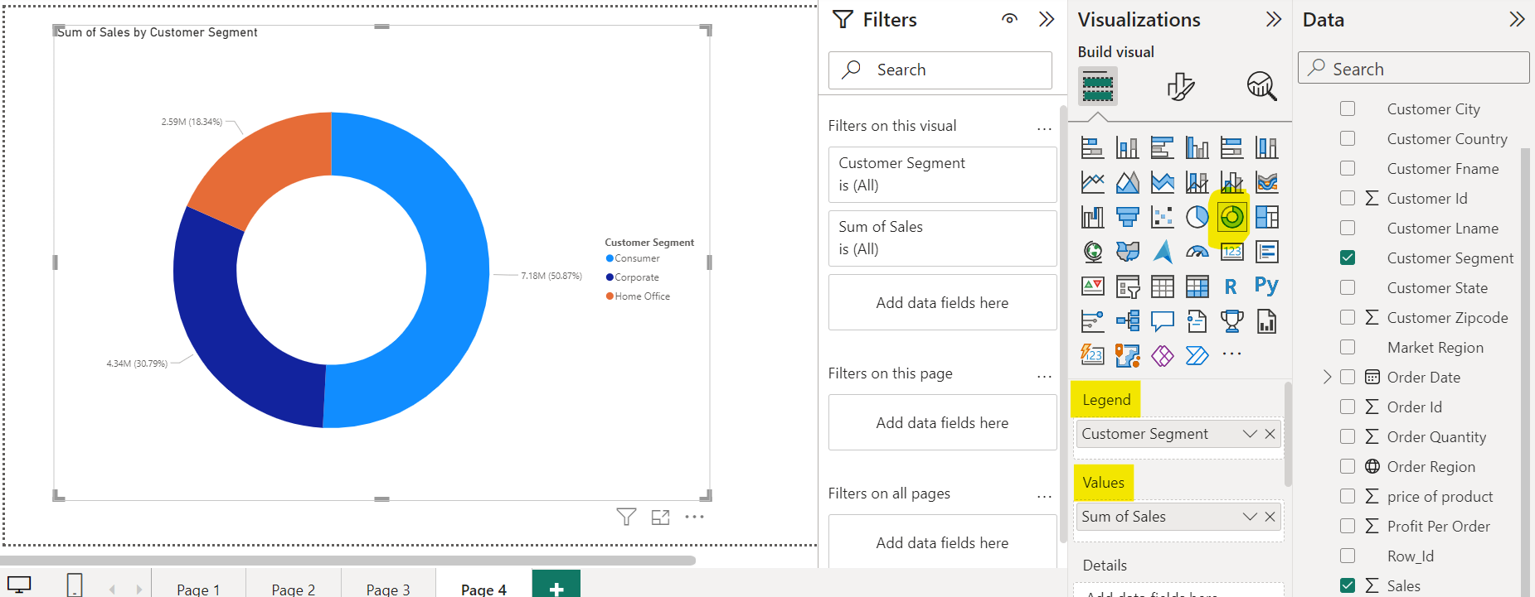
  + Pie Chart
  + 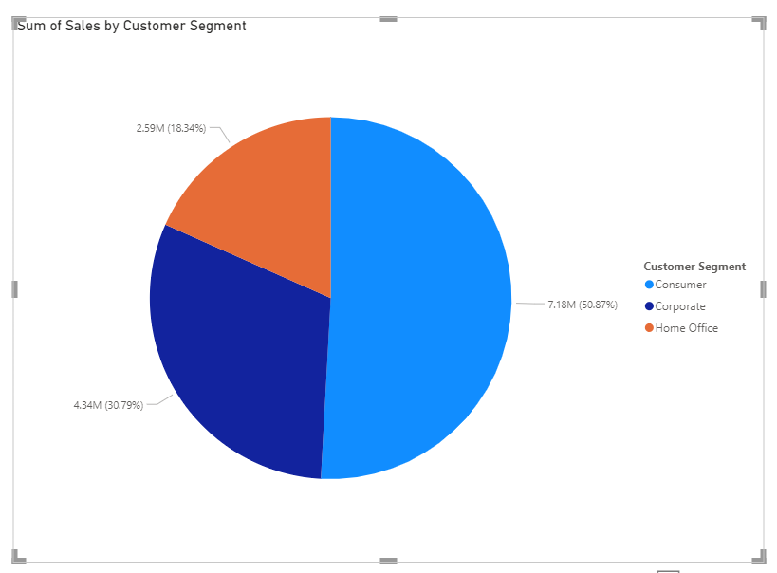
  + Tree Map Chart: We can see cleats are most ordered, but we can check it has not much profit as compared from other product.
  + 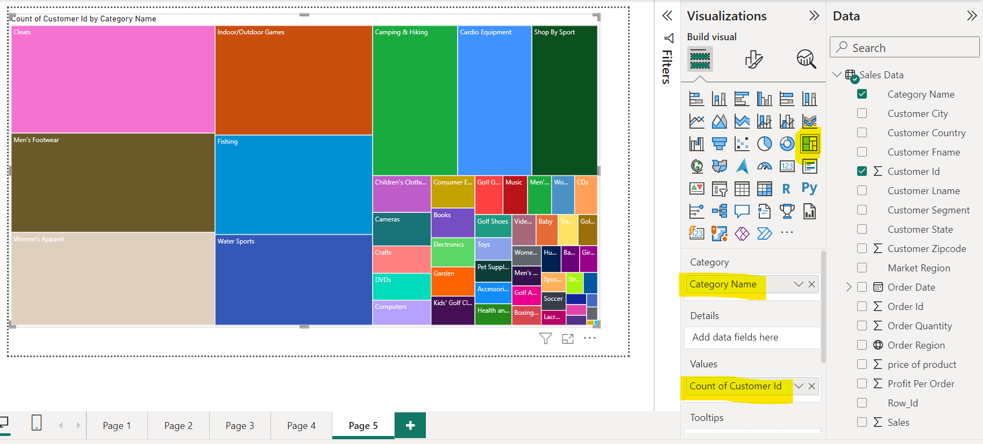
* Geographical Plot
* 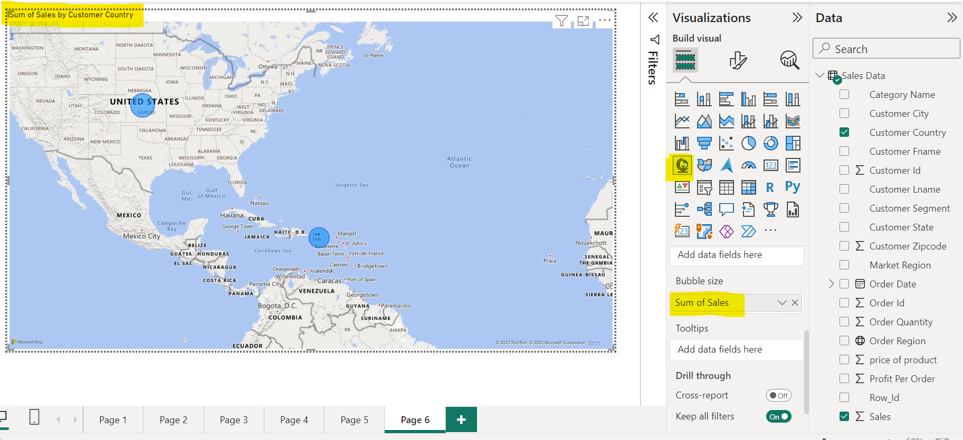
* Legends dene pe har circle me plot ho jaayega legends.
* 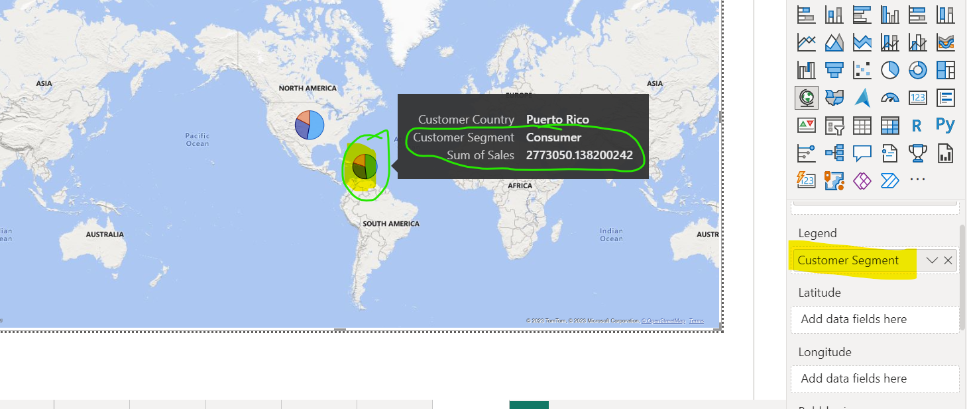
* For more option goto File->Options and setings -> Options ->Security -> Check use map and filled map visuals
* 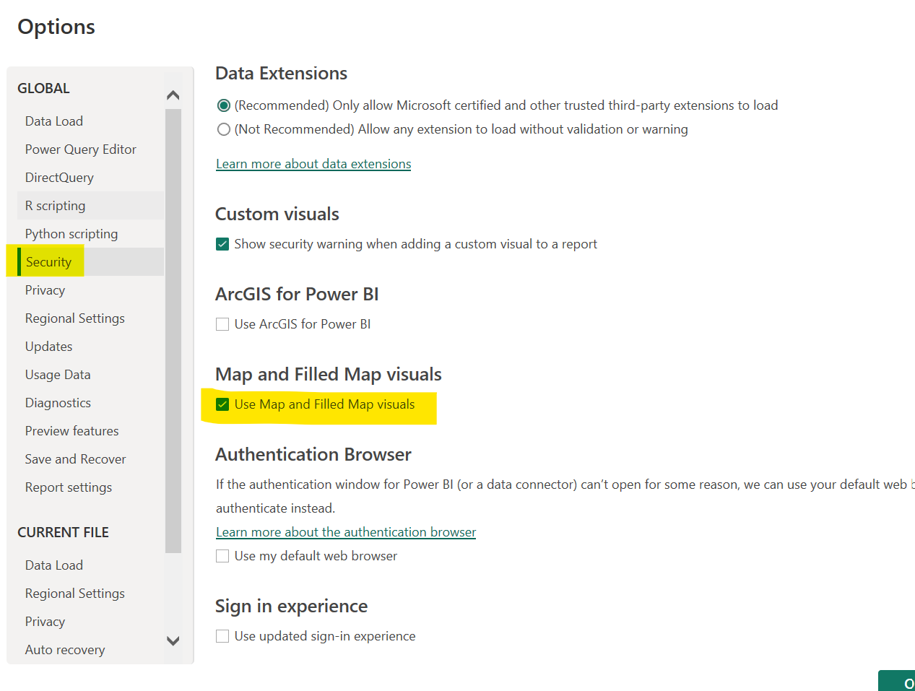
* KPI : key Performance Indicator
* 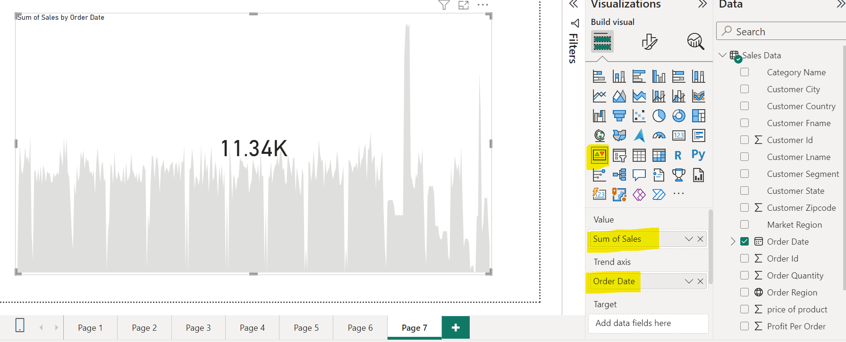
* Slicer is on screen filter.
* 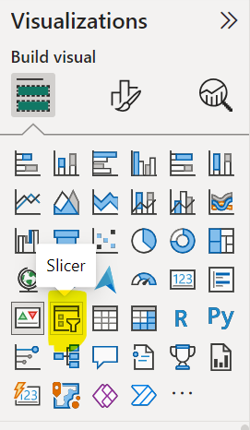
* 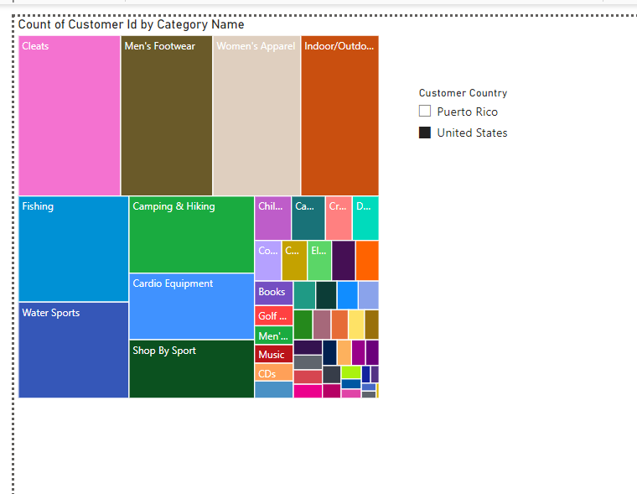
* Whole dashboard data will be filtered from slicer.
* Create a dashboard your self

**LECTURE- 04**

* Use this data dataset 
* It contains 3 tables import all.
* Model View
* 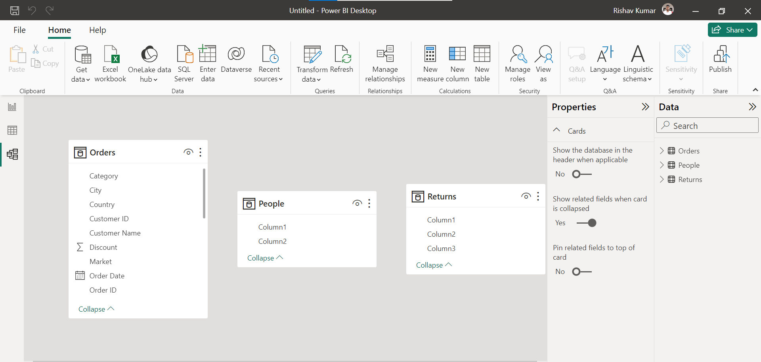
* Columns of people and Returns are not appropriate so we will transform data.
* Goto transform data. Power Query Editor will be entered.
* 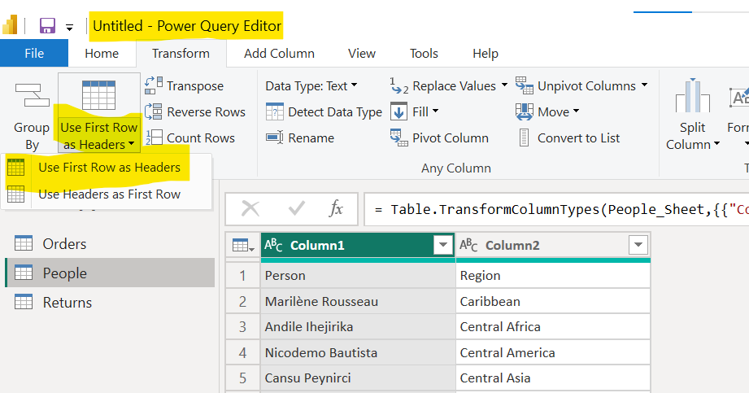
* Change data type of column accordingly.
* Check null value and appropriate data type assigned to aech column.
* Check column quality.
* It is empty column, so we can remove it.
* 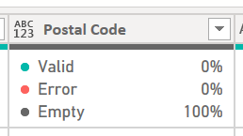
* Remove redundant rows.
* 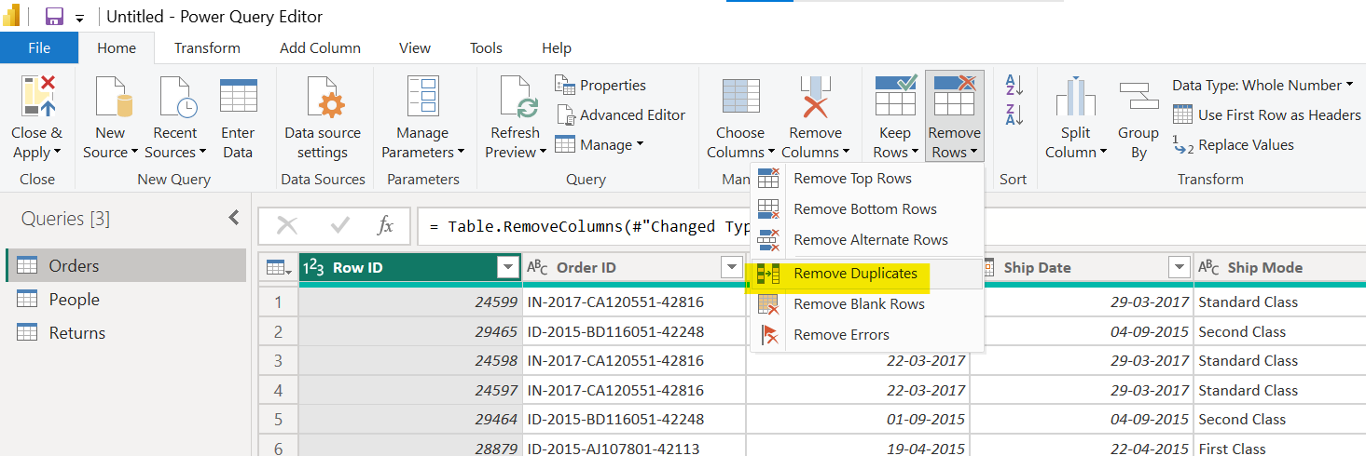
* We can remove duplicates from column wise as well.
* Merge or split columns.
* Remove city column
* Discount has 0 and 1 value so we will keep it. If 1 hi value hoti to remove kar sakte the.
* Calculate ship time=Ship Date – Order Date
* 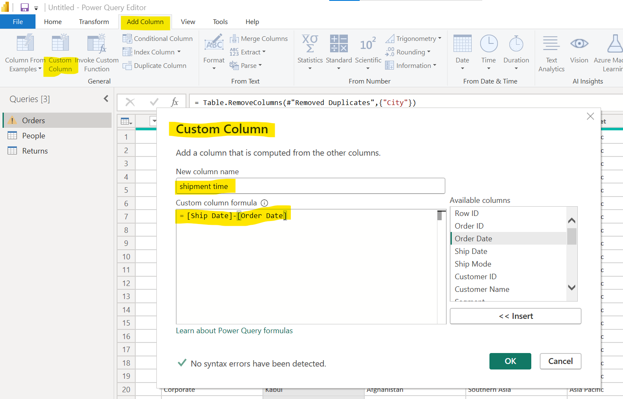
* Change data type of shipment col to whole number then we will get exactly no of days.
* Below is actual m-query for creating shipment time column.
* 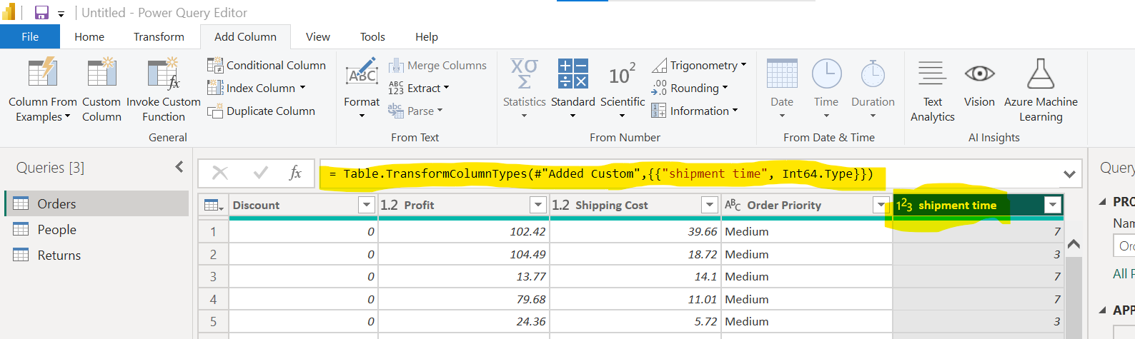
* M-query for calculating shipment time.
* 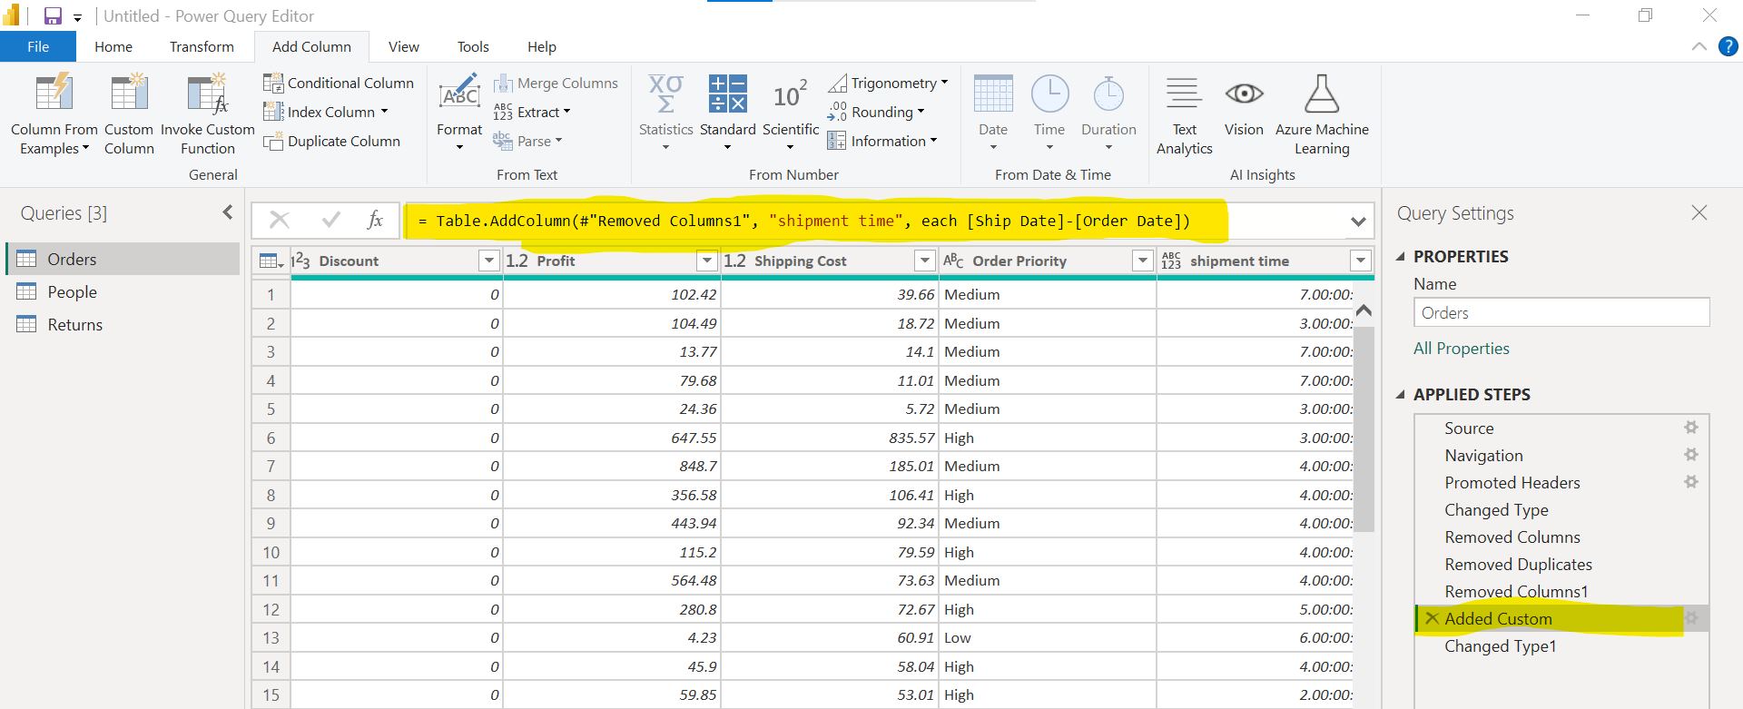
* Close and apply
* Data Modelling: connecting table each other. For relationship.
* 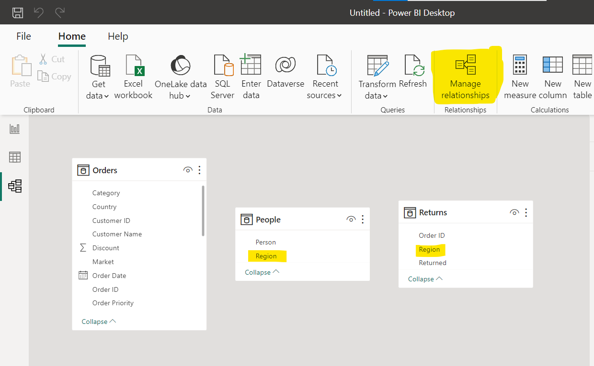
* PowerBi can detect automatically or we can make relationship ourself.
* 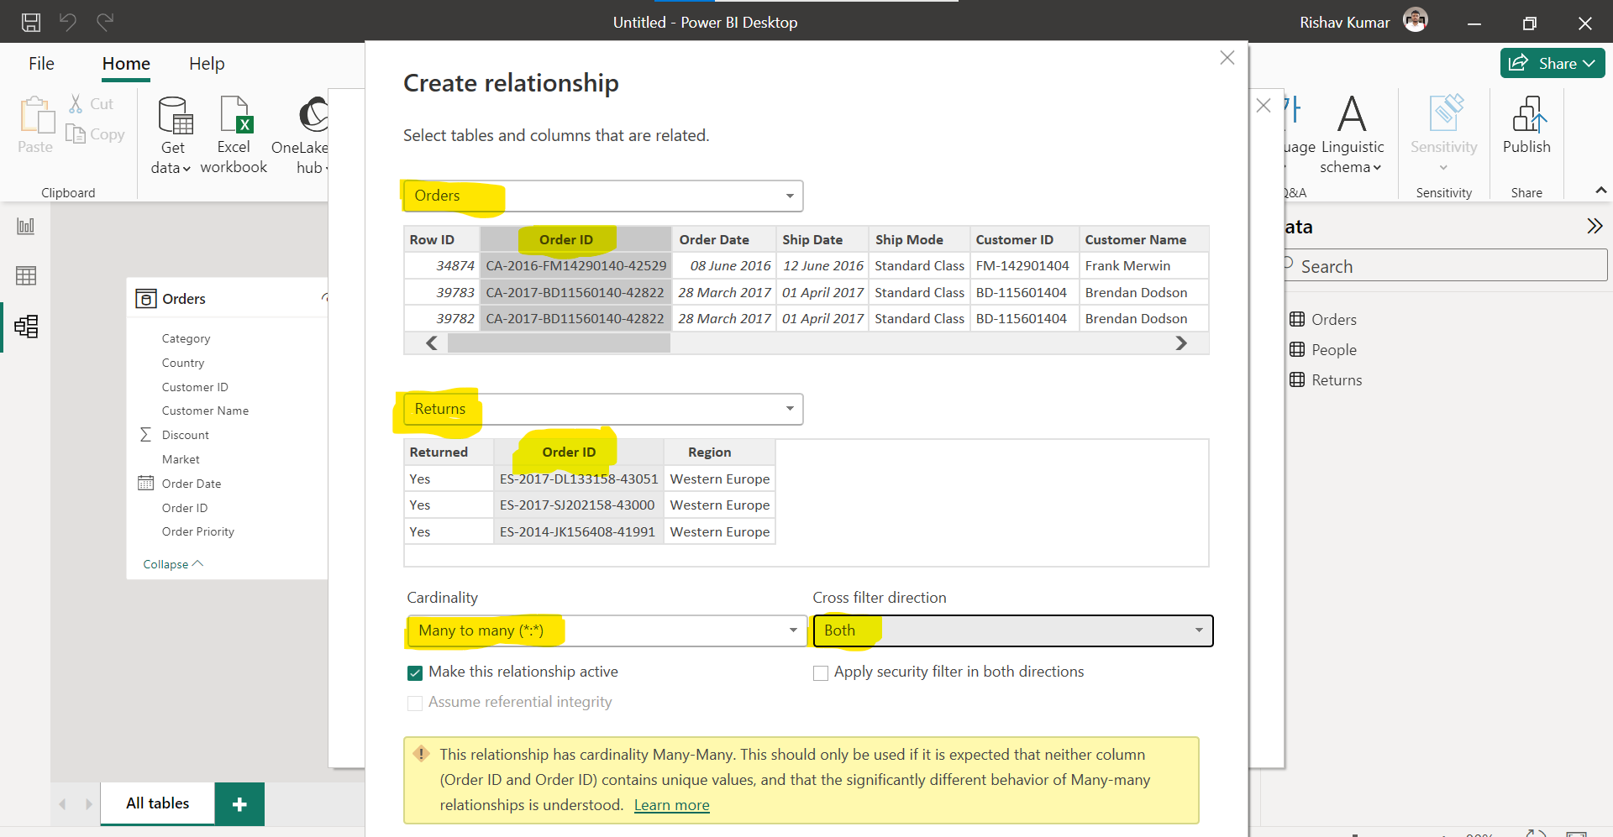
* 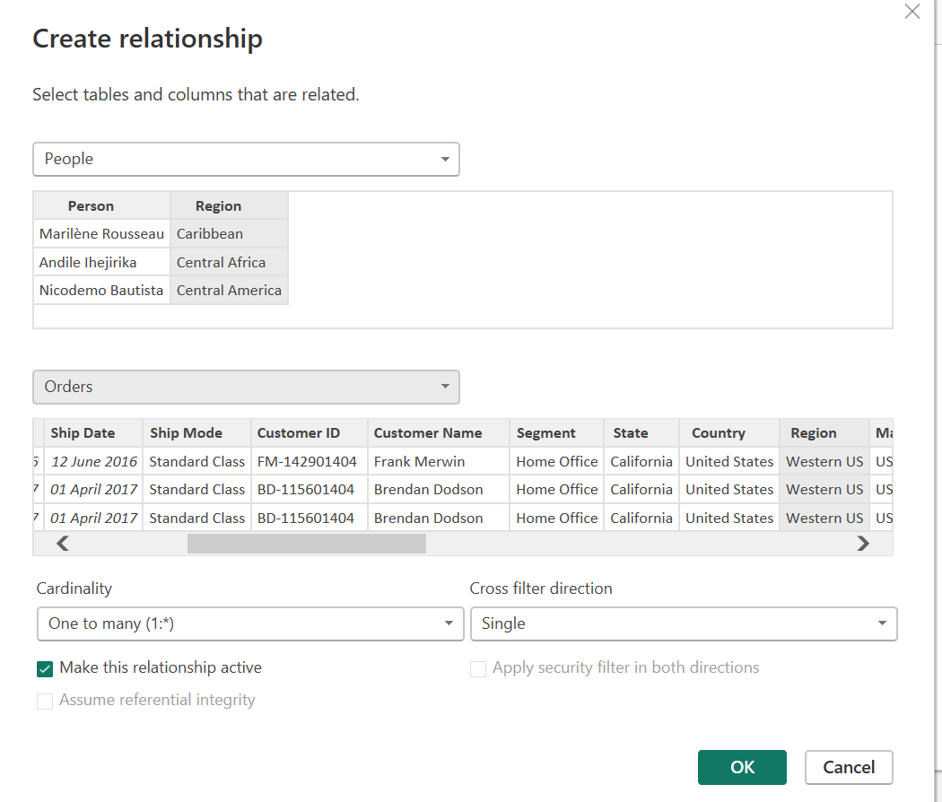
* 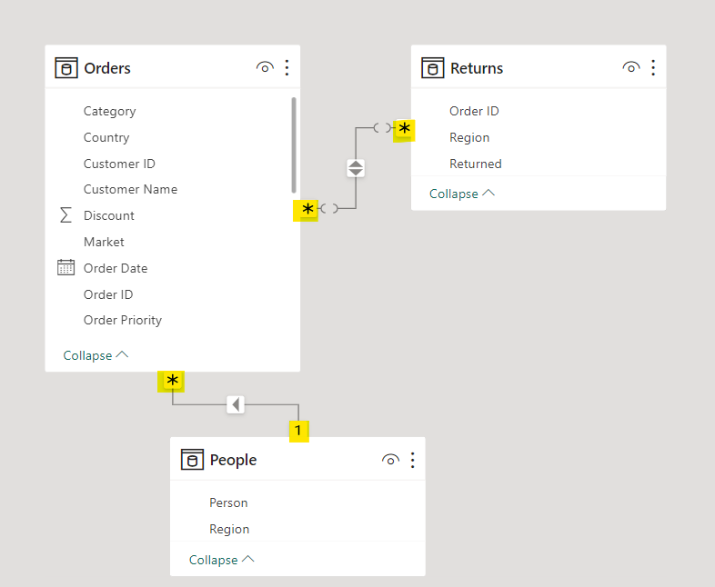
* Change data type from here. 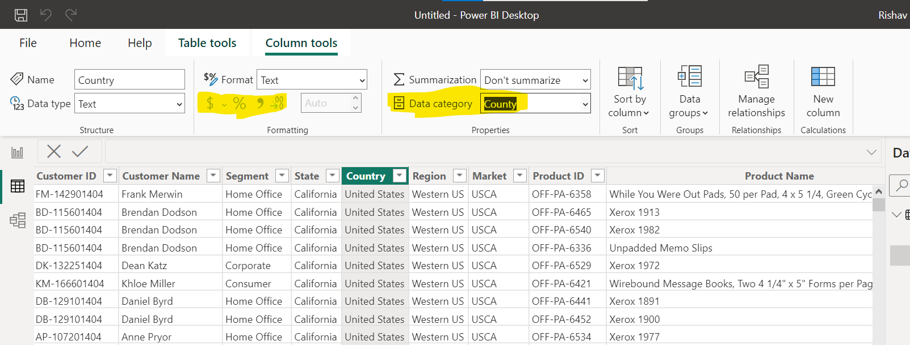
* 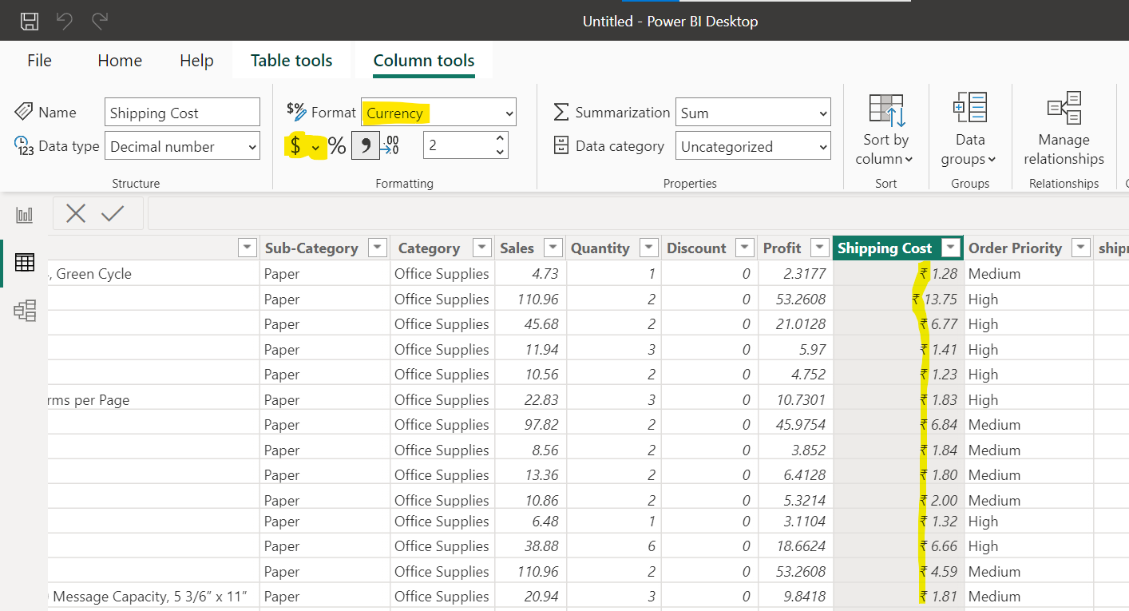
* Line chart is used to see trends over the period. We can add legends to see different category over the period.

05 LECTURES

* Total sum sales = SUM(Orders[Sales]) //DAX formula= Data Analysis Expression
* 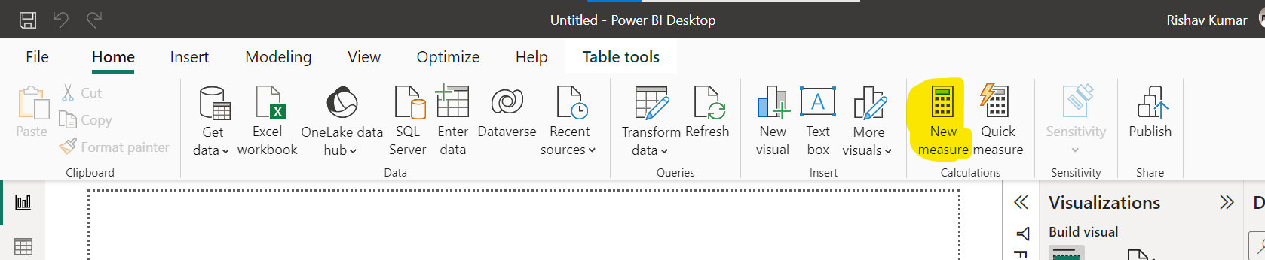
* 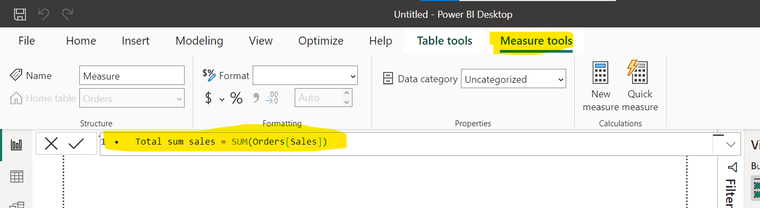
* 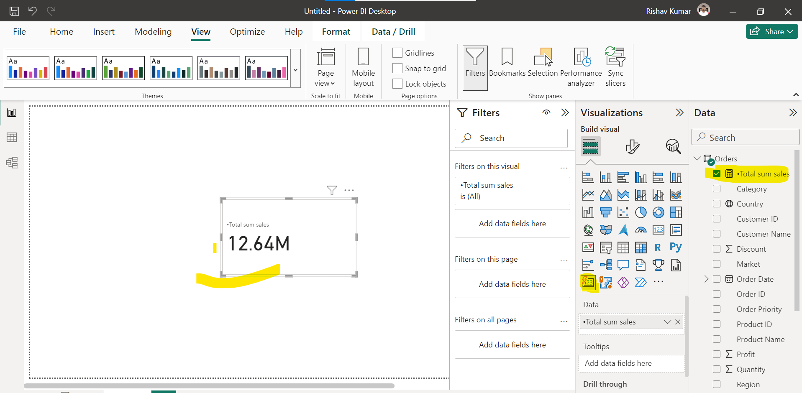
* indian profit = CALCULATE(sum(Orders[Profit]), 'Orders'[Country]="India")
* 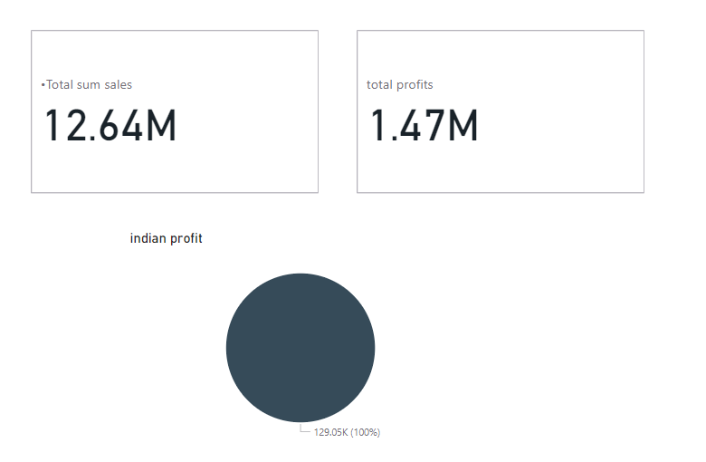
* There are some predefined formula and AI calculations available.
* 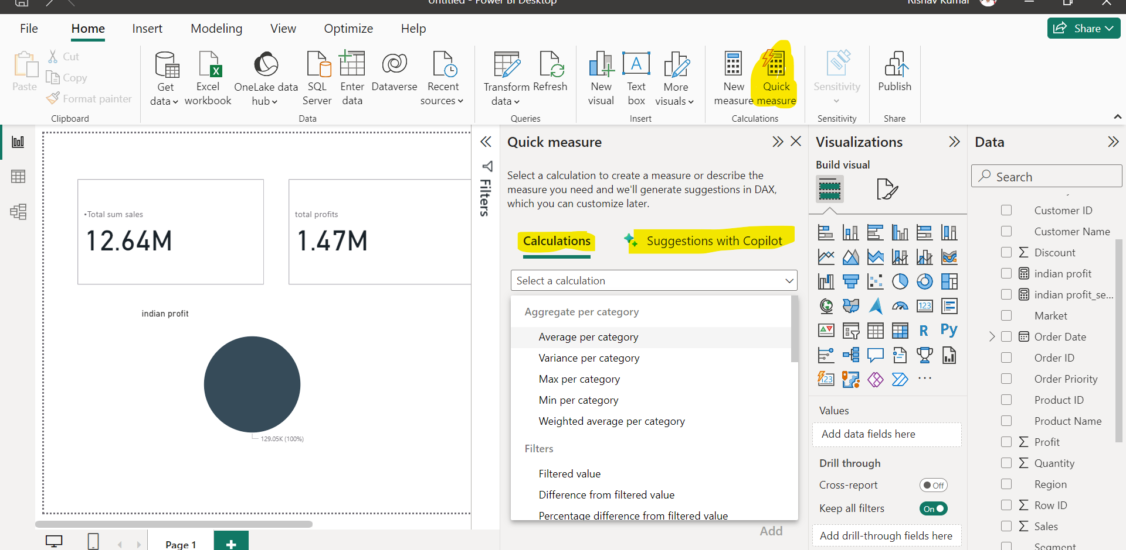
* 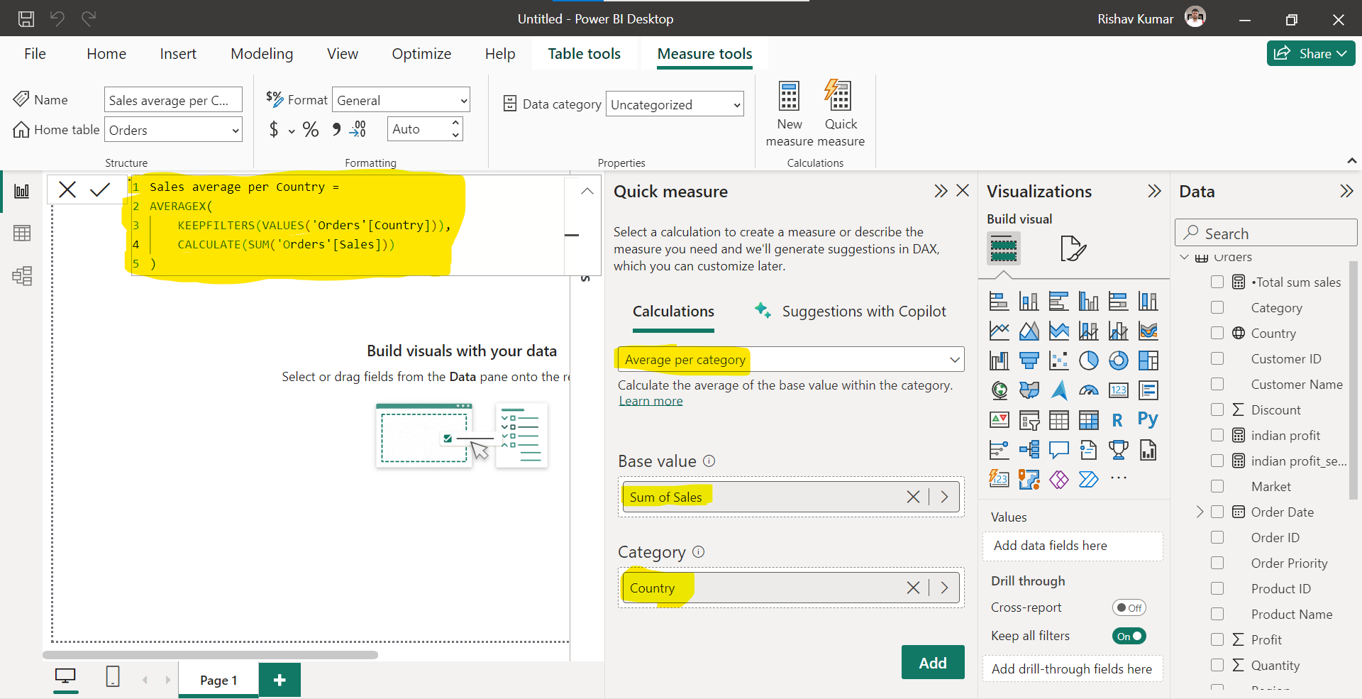
* 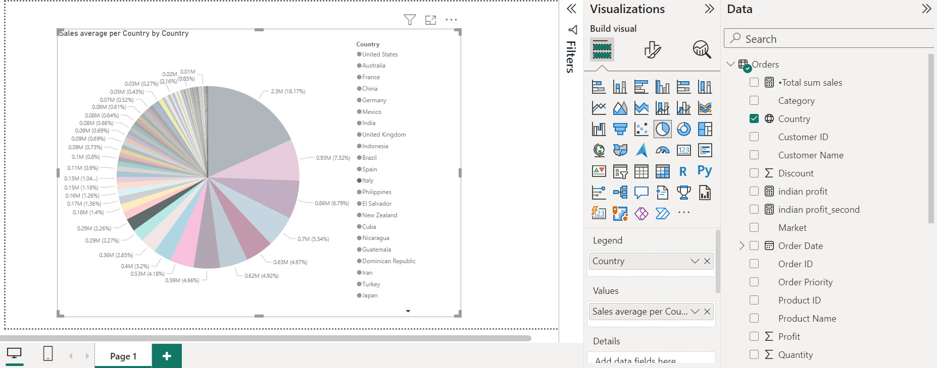
* Visit DAX Function reference webpages to learn more about all formula of DAX.
* DAX is like applying formula on already filtered data.
* 

Lecture 06

* This is deep learning class

Lecture 07

* We learnt about different types of data source e.g. sql, no-sql, ms azure and many more
* Getting data from web page like… data, page source code, tables etc.
* 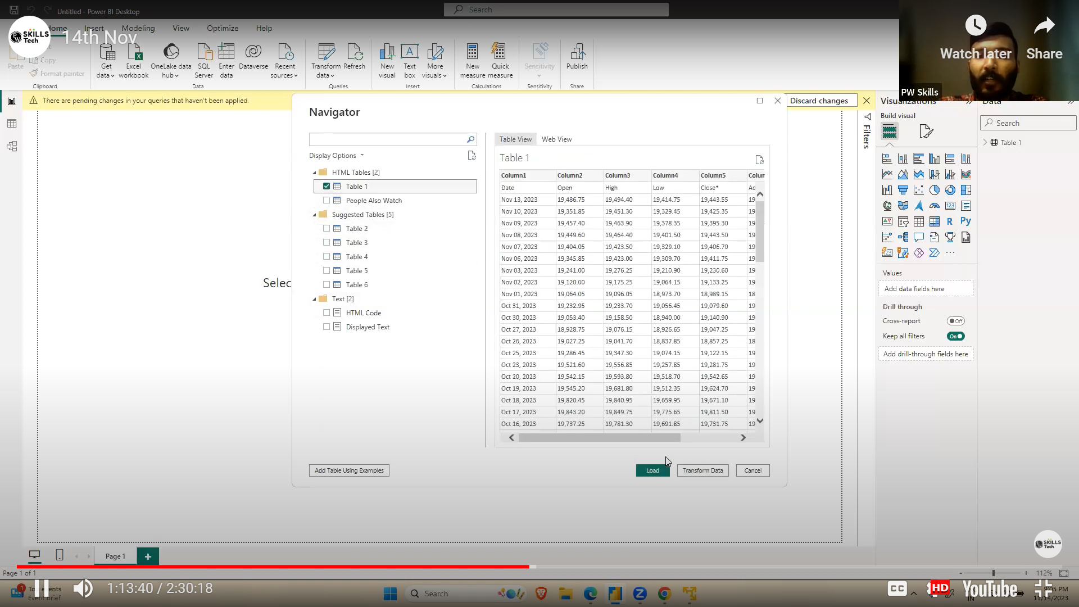
* 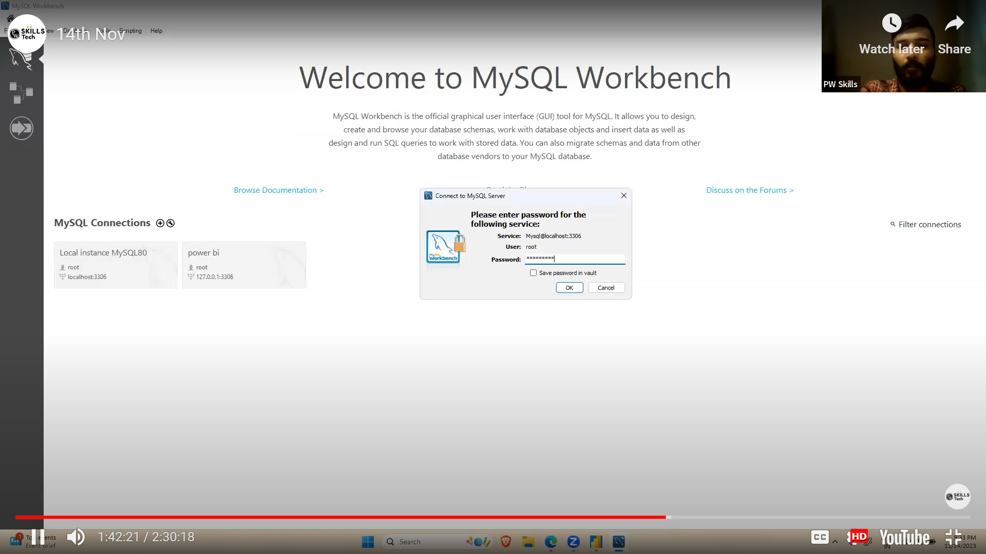
* 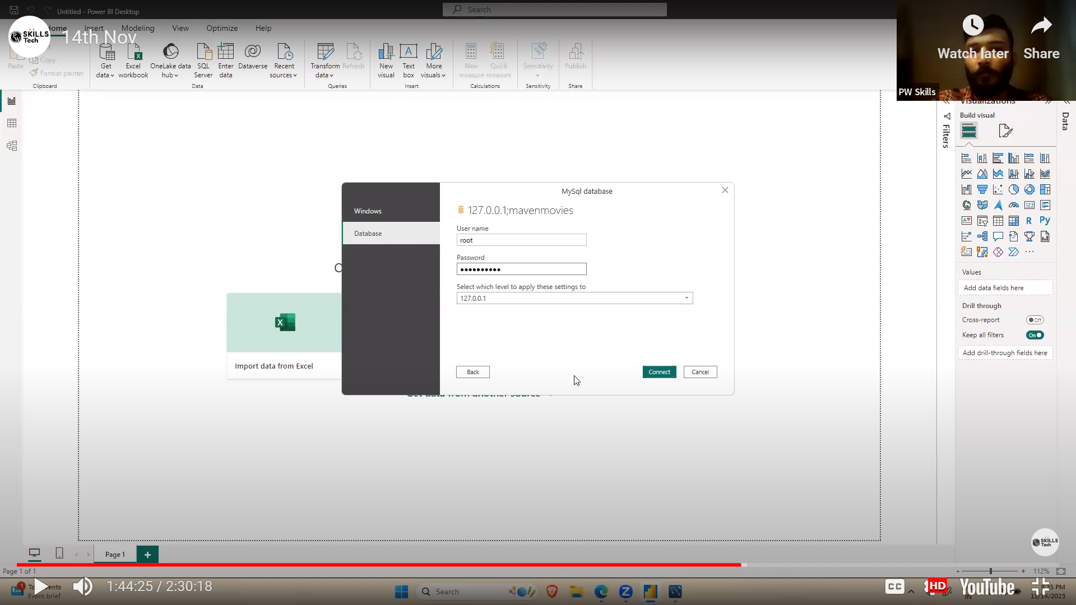
* 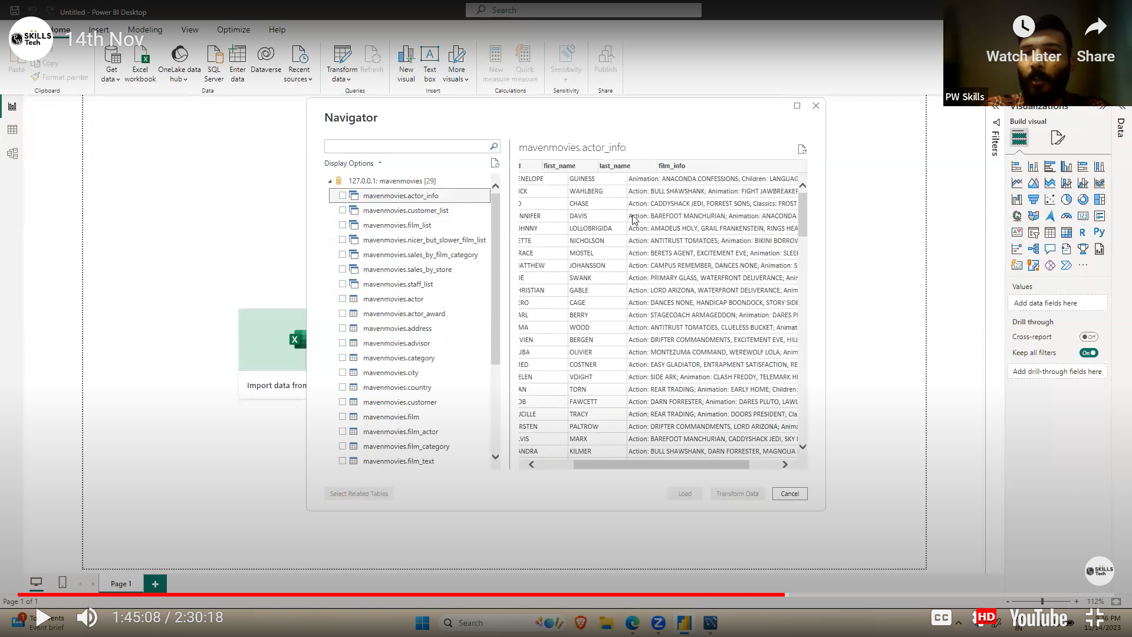
* 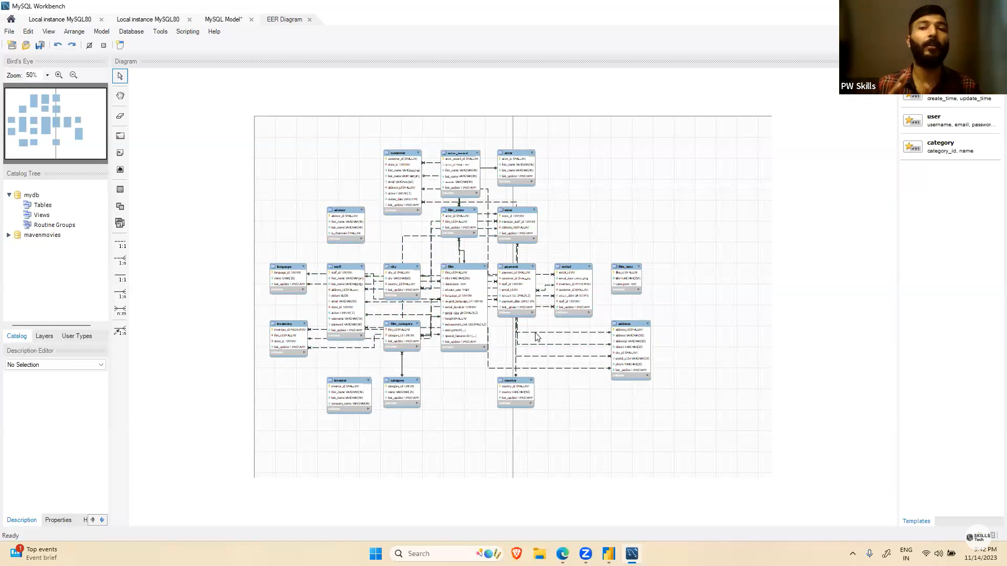
* 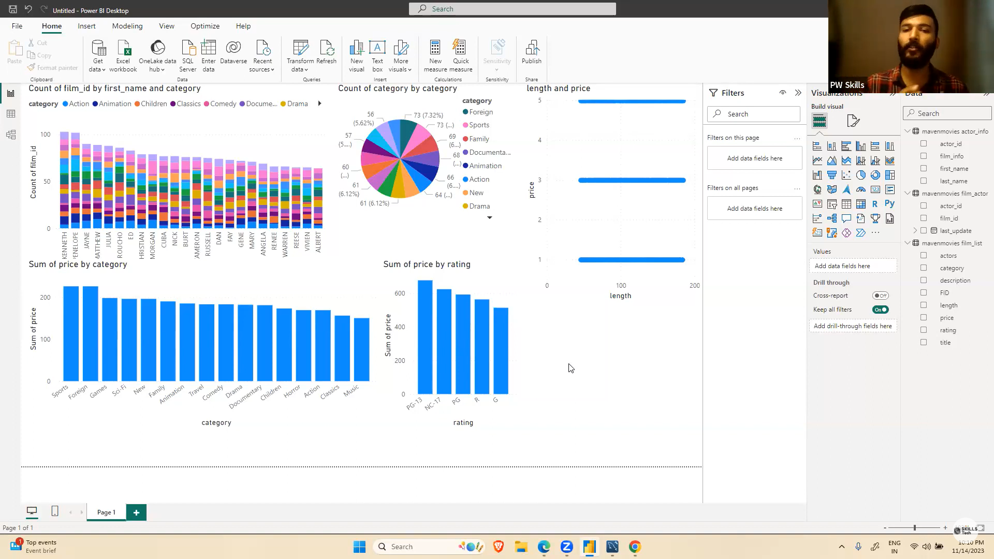

Lecture 08

* We have setup Microsoft sql workbench.
* We imported data through it.
* Analysed and setup relationship between tables.

Lecture 9

* Data cleaning, chart preparation.
* PowerBi github download data and chart

Lecture 10

* Did more analysis and better visualization